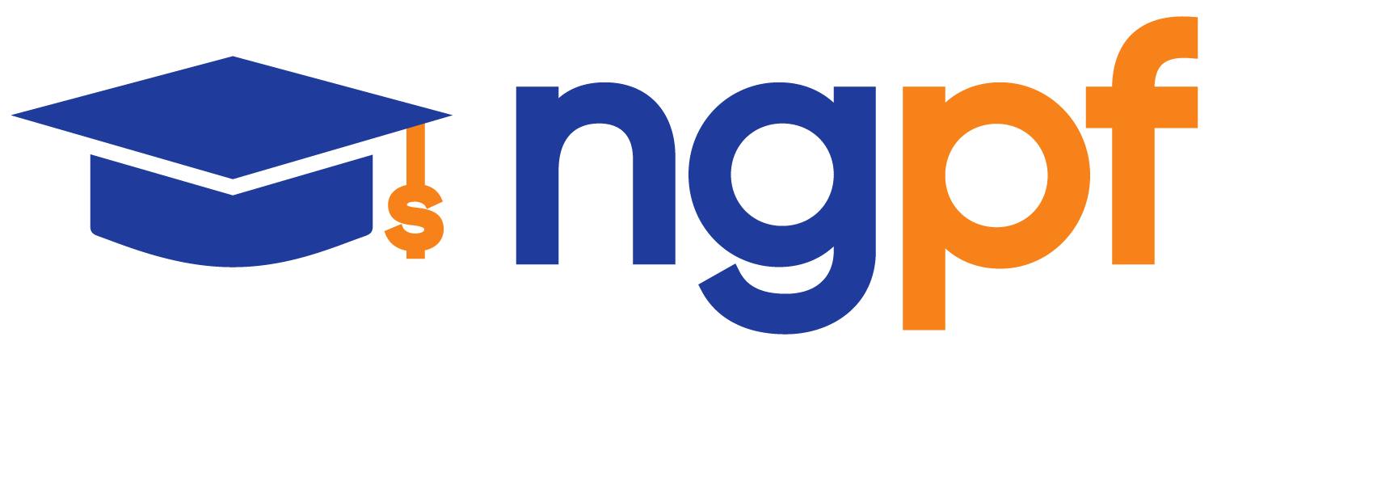

2.8 Online and Mobile Banking

Student Activity Packet

UNIT: BANKING

Name:

Students will be able to:
- List the advantages of online and mobile banking versus traditional banking
- Explain what online bill pay is and how recurring payments work
- Enumerate the benefits of direct deposit for their paychecks
- Compare and contrast various peer-to-peer payment apps
- Explain how to bank safely online
- Explore the pros and cons of a cashless society

NOTE: Vocabulary for this unit can be found in the NGPF Personal Finance Dictionary

INTRO

DATA CRUNCH: How Do Consumers Use Mobile Banking?
Analyze the image on the worksheet to answer the questions on this Data Crunch.

LEARN IT

ARTICLE: The Advantages of Personal Internet Banking

Mobile banking uses smart phone apps to interact with your bank accounts. Online banking is a more broad category that includes any device that is connected to the internet. Being able to conduct transactions online and on our phones has reduced the need for people to go to banks in person and do things on paper. Read the Advantages section of the article to learn more about the benefits of online banking. Then, answer the questions.

- The article listed 7 major advantages of online banking. Choose 2 and, in your own words, explain how they can make banking easier or more convenient.

- Do you already conduct your banking online or through your phone? If yes, which of these advantages do you find helpful? If not, which of these do you think you would find to be the most helpful? Why?

ARTICLE: Online Bill Pay: What It Is and Why to Use It
In the Data Crunch, you saw that many people are utilizing online and mobile banking with their checking accounts. They love the convenience and time-saving features of online banking, including the ability to pay their bills online. Skim this article to learn more. Then, answer the questions.

- What might be the benefit of setting up a recurring payment through online bill pay?

- Picture yourself moving out on your own or maybe with a roommate, working your first full-time job. List at least four people or companies you might want to pay regularly by using online bill pay.

VIDEO: What is Direct Deposit?
Another feature online banking offers is Direct Deposit, which is now the most common form of payment for work. Watch this video to learn what some of the benefits of direct deposit are. Then, answer the following questions.

- In your own words, explain what direct deposit is.

- What information will you need to provide to your employer to set up direct deposit?

- What are the benefits of using direct deposit?

DO IT

ACTIVITY: INTERACTIVE: Online Bank Simulator
Now that we’ve explored the most important aspects of banking, let’s try using an online bank. Follow the directions on the worksheet to complete this activity.

LEARN IT

ARTICLE: Is Online Banking Safe? How to Boost Your Banking Security
With many transactions like payments and direct deposits happening online, you might be concerned about the safety of your money. Read the article to learn about ways that you can improve your online banking security and protect your money. Then, answer the questions.

- Why is it recommended that you avoid doing online banking on public Wi-Fi?

- How can turning on text and email alerts help keep your account safe?

ARTICLE: The Pros and Cons of Moving to a Cashless Society
Another major change is a move towards a cashless society. Being cashless offers many conveniences, but it’s not without its downsides. Read the article up to “What Does a Cashless Society Look Like?” Then, answer the questions.

- In your own words, what is a cashless society?

- How does a cashless society affect your privacy?

- How does a cashless society affect the economically disadvantaged?

- How might a cashless society negatively impact someone who is unbanked or underbanked?

EXIT TICKET

Follow your teacher’s directions to complete the Exit Ticket.

