Financial Institutions and You
Assignment #2

Name: __________________________________________

- Explain the main difference between a chequing account and a savings account by describing what scenario you would use each type of account in.

- Use the FCAC Account Comparison Tool to compare two different types of chequing accounts for students.

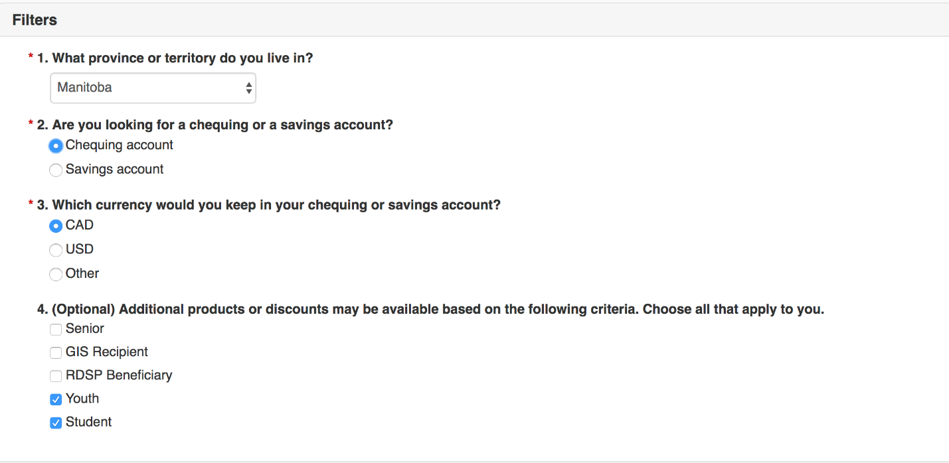
Your basic search critera should look like this image; however, if you wish to add additional criteria tailored to your personal requirements feel free.

Using the results of your search, fill in the table on the following page to compare two different chequing accounts.

Option #1 | Option #2
Product Name: | Product Name:
Name of Bank or Credit Union: | Name of Bank or Credit Union:
Included Transactions: | Included Transactions:
Interest Rate: | Interest Rate:
Monthly Fee: | Monthly Fee:
Withdrawal Fees: | Withdrawal Fees:
Transfer Fees: | Transfer Fees:
Overdraft Protection Fees: | Overdraft Protection Fees:
NSF Fees: | NSF Fees:
Debit Card Purchase Information: | Debit Card Purchase Information:
Bill Payment Fees | Bill Payment Fees
Additional Features/Notes | Additional Features/Notes

- Which account package would you personally choose? Explain why.

- https://www.canada.ca/en/financial-consumer-agency/services/banking/opening-bank-account.html#toc0
What are the two basic things you need to do in order to open an account at a bank or credit union?

- https://www.canada.ca/en/financial-consumer-agency/services/banking/atm-fees.html
What are the types of ATM fees you may need to pay?
Who owns the ATM you’re withdrawing from | Regular account fee | Network access fee | Convenience fee (charged by another financial institution or private operator) | Total transaction cost
Your own financial institution
Financial institution you don’t have an account with
Private operator

- Tips for saving ATM fees:

- Use the word bank below to match the key terms to the following definitions.

- The annual interest percentage paid on a bank account.

- Whenever you withdraw money from a bank account this is the term the bank uses to describe its liability to you decreasing. Funds are going OUT of your account.
- A written agreement that orders your bank to pay out a sum of money to a specific person or organization.
- Money that is placed into an account at a financial institution for safekeeping.

- An agreement between you and your bank that allows you to withdraw more money than what you have in your account.
- Having access to your bank accounts via the Internet.

- The act of taking money out of an account at a financial institution.

- A charge for a service or a penalty for not meeting the requirements of the account agreement with your bank.
- A type of cheque where the bank has already guaranteed that there are sufficient funds to cover the payment.
- Whenever you deposit money into a bank account this is the term the bank uses to describe its liability to you increasing. Funds are going IN to your account.
- Any financial event that occurs such as a deposit or a withdrawal.

- The amount some banks require you to keep in your bank account in order to avoid paying extra fees.
- The transfer of funds from one bank account to another via the Internet.

- The amount of money in your bank account at a specific moment in time.

- An employee of a financial institution whose job includes helping customers or members complete banking transactions.
- A situation where you submit funds to a bank or credit union and they then issue a draft to the desired payee.
- An ATM card that can be used to pay for goods and services by drawing money directly from the bank account that it is linked to.
- A situation where your account balance is too low to cover a debit card purchase or cheque payment.
- An electronic banking device that allows customers to complete basic transactions without the help of a teller or banking representative.
- A box or safe that is located inside a financial institution that is used to store valuables such as documents and jewelry.

Word Bank

- Account Balance
- ATM
- Bank Draft
- Certified Cheque
- Cheque
- Credit
- Debit
- Debit Card
- Deposit
- Electronic Transfer
- Interest Rate
- Minimum Balance
- NSF
- Online Banking
- Overdraft Protection
- Safety Deposit Box
- Service Fees
- Teller
- Transaction
- Withdrawal

