4.1 Intro to Credit

Student Activity Packet

UNIT: TYPES OF CREDIT

Name:

Students will be able to:
- Identify the major types of credit and their characteristics
- Understand the three basic components of lines of credit: principal, interest rate, and term
- Define net worth and how it is calculated

NOTE: Vocabulary for this unit can be found in the NGPF Personal Finance Dictionary

INTRO

PROMPT
Use the space below to answer the prompt.

- Reflect on a time where you borrowed from or lent money to someone.
  - Who did the loan involve?
  - What was the agreement for repayment?
  - Did the agreement work out the way you anticipated?
  - Were both people happy at the end?

LEARN IT

EDPUZZLE: Loan Basics
Perhaps you’ve casually lent or borrowed money from a friend before. But more formal loan arrangements from a financial institution come with far more terms you must understand in order to get a fair deal. Watch this video and follow your teacher's directions to answer the questions either in your student activity packet or within the EdPuzzle itself.

- The details of any loan will include the following 3 components:
  - The principal, the interest rate, and the loan term
  - The money you pay, the money the lender pays, and the principal
  - The mortgage, the auto loan, and the small business loan
  - The loan amount, the credit card payment, and the statement

- Why are secured loans considered less risky to the lender?
  - Lenders are allowed to conduct background checks for secured loans
  - Lenders can take valuable collateral if you fail to repay your loan
  - Lenders give secured loans all the time, so they're more comfortable doing them
  - Lenders can check your credit score before giving a secured loan, which they can't do for an unsecured loan

- Having a good credit score, making a larger down payment, and finding a cosigner with good credit are all ways to…
  - Decrease your principal
  - Decrease your interest rate
  - Increase your term
  - Increase your total payments

- Each of these statements describes a variable rate loan EXCEPT...
  - Typically starts with a lower interest rate than a fixed rate loan
  - Is riskier to the borrower because the interest rate could increase substantially
  - Is almost always a better option
  - Can increase or decrease the interest rate over the course of the loan

DO IT

ACTIVITY: MOVE: Credit Musical Chairs
The previous video discussed loans, but there’s another type of credit you’ve likely heard of – credit cards. This activity will allow you to dive in deeper to categorize some of the most popular forms of credit. Follow your teacher’s directions to complete this activity.

LEARN IT

INFOGRAPHIC: What’s My Net Worth?
Many people think that being wealthy means you have a lot of stuff; however, it turns out that what you own is only part of the equation for determining your net worth. Review this infographic to see how wealth or net worth (often used as synonyms) is calculated. Then answer the questions below.

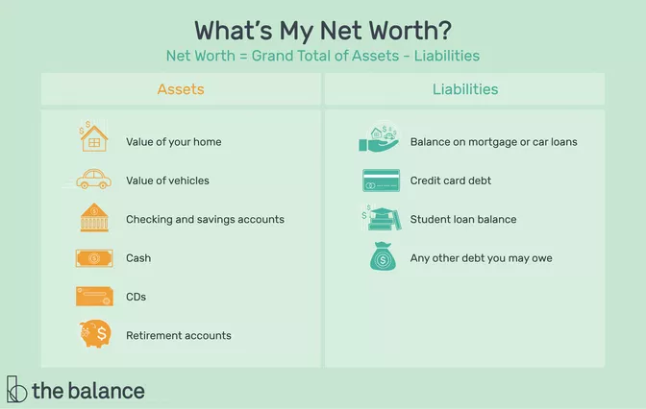

Source

- Your friends and you notice a neighbor who always has brand new clothes, shoes, and electronics. What would you need to know in order to tell if this neighbor is actually wealthy?

- There’s not one target net worth value that is universally considered to be “rich” or “wealthy.” But right now, Sanya’s net worth is $12,000. Her goal is to have a net worth of at least $100,000 before she turns 35.

  - Explain one way that using credit could help Sanya achieve her goal.

  - Explain one way that using credit could hurt Sanya’s progress.

EXIT TICKET

Follow your teacher’s directions to complete the Exit Ticket.

