PHOTOSHOP CHALLENGE - SPOT COLOUR
- Open TWO of your own colour photos (or you could use Google images) in Photoshop.
- Duplicate the Background layer.
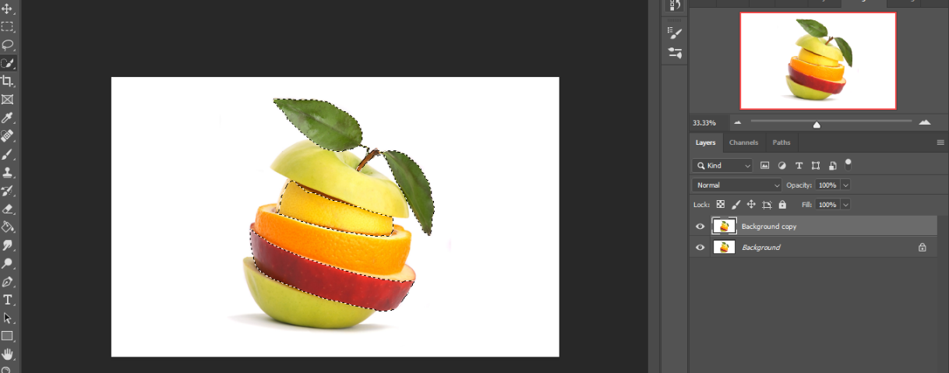
- Select the background copy. Choose a selection tool (quick selection, lasso, marquee—whatever works best for the kind of selection you want to do) and select around the object/s you want to keep in colour.
You should have travelling ants around all the objects you want to keep in colour.
- Once you have a good selection of the object you want to keep in colour, go to Layer → New (first option under layer) → Layer via Copy.
- Deselect the selection if selected (ctrl + d).
- Make your Background Copy layer black and white. Make sure you are on your Background layer. Go to:
- Custom Black and White (Image → Adjustments → Black & White)
- Use sliders to adjust highlights and shadows.

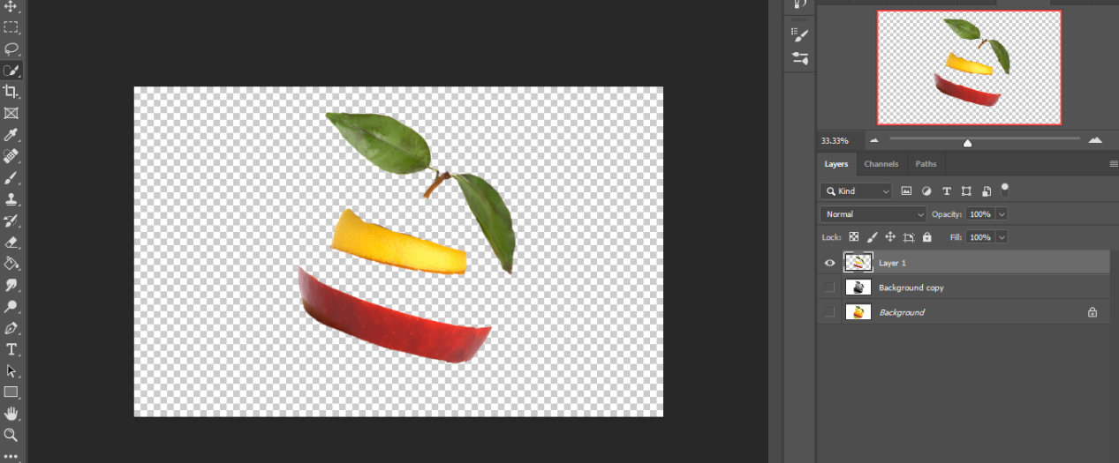
- You can erase, blur/smudge the edges on the new layer/selections to smooth them out. You may want to hide the other layers to make it easier.
Smudge or blur
Eraser

- Save as a PSD.
- Flatten Image and save as a JPEG.
- Post the original image + your edited JPEG file on your Weebly. No need for a caption.

Sample:
Original Photo Spot Colour
You should have 4 pictures posted to your Weebly (2 originals and 2 edited)

