`

NGPF Activity Bank
Types of Credit
Spanish Version

ANALYZE: Understanding Amortization
Janet just graduated from college, has a job she’s scheduled to begin in 3 months and has decided to treat herself to 6 weeks of travel across South America before she buckles down and starts working full-time. To do the trip, she’s thinking of applying for a personal loan of $3500, and the bank she uses for her checking and savings account has offered her an interest rate of 24%. She has a goal of paying off the trip within two years, so she uses a Bankrate.com loan calculator with a starting date of 2/22/22 and gets the following amortization schedule:

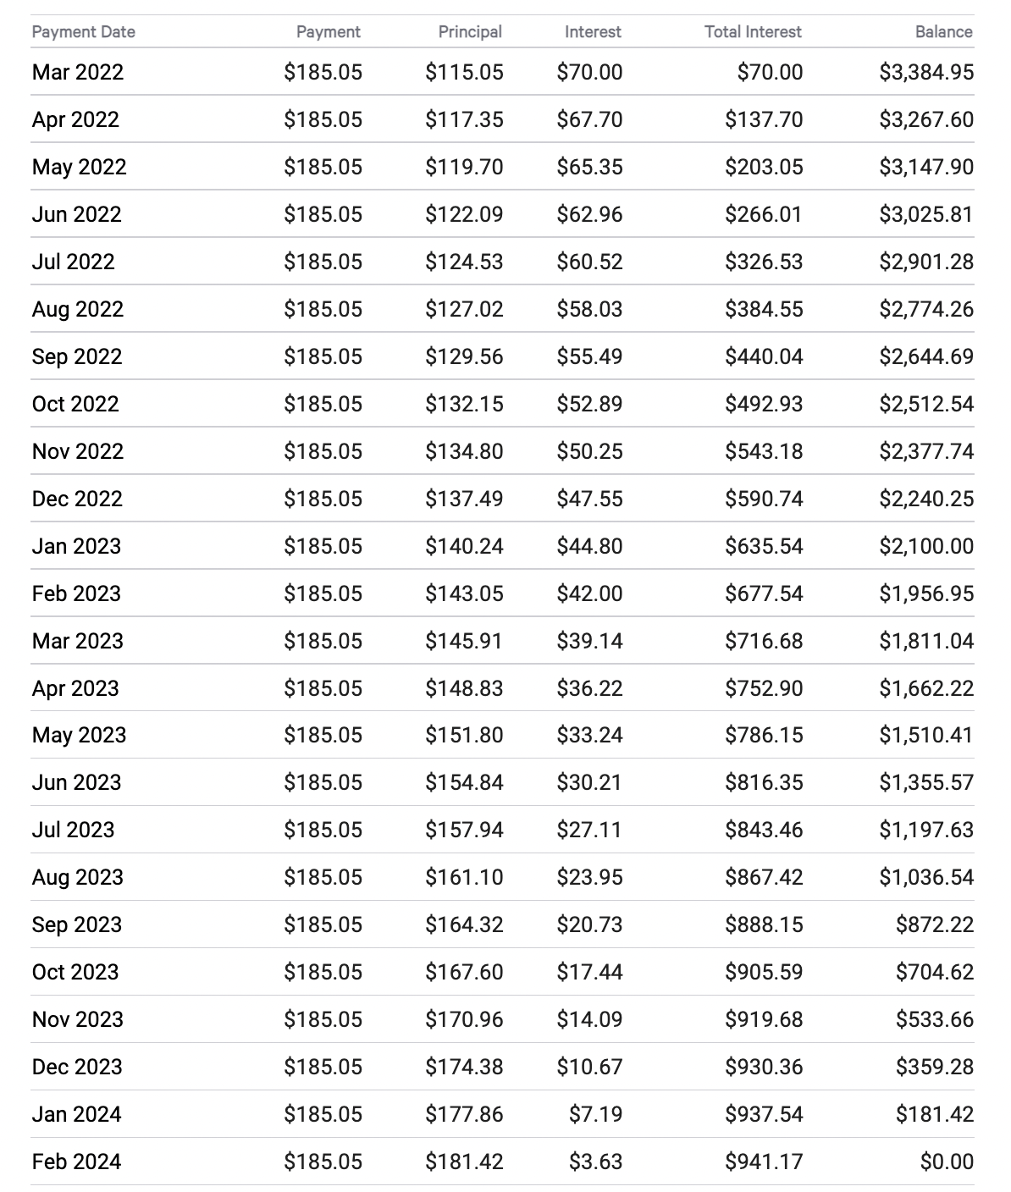

Part I: Amortization Basics
Answer the following questions using the amortization schedule above.

- How much is Janet going to pay every month?

- On Mar 1, 2022, how much of Janet’s payment goes toward:
  - interest?

  - principal?

- Look at Janet’s repayment on April 1, 2022.
  - How do the interest and principal compare to what she paid in the previous month?

  - Explain why this happened.

- By the time Janet pays off her entire loan,
  - How much interest will she have paid?

  - How much will the trip have cost her in total?

- Let’s suppose Janet received a year-end bonus and can afford to pay $285.05 during March 2023.
  - Rewrite the line of the amortization schedule for 3/1/2023 using her new payment.

DATE | PAYMENT | PRINCIPAL | INTEREST | TOTAL INTEREST | BALANCE
3/1/2023 | $285.05

  - What will be the general impact on Janet’s amortization schedule by making this single larger payment?

Part II: Change Janet’s Schedule
In question 5 above, you calculated what the schedule would look like if Janet had made one $285.05 payment in March 2023. You did it by hand, but the Bankrate calculator has a feature that allows you to adjust the entire schedule.

- Using the Bankrate.com loan calculator, enter in the original loan amount, loan term, and interest rate.
- Then, click on “Calculate” to get the monthly loan payment of $185.05.
- Click “Show Amortization Schedule” and scroll down to the table. Make sure that the “Start Date” of the payment in the table is 02/22/2022.
- Click on “ADD EXTRA PAYMENTS” under the blue Calculate button. Add an extra one-time payment of $100 in March 2023 and click the blue button “APPLY EXTRA PAYMENTS.”
- Now, scroll down to March 2023 in the amortization table. You should see that there is now a one-time payment of $285.05 for that month.

  - How did the extra, one-time payment of $100 affect the total interest Janet pays on the loan?

  - What was the impact on the number of months it will take Janet to pay off her loan?

- This new calculation has Janet curious -- if she’d been making $285.05 payments for the entire duration of the loan*,
  - what would be the impact on the total interest Janet would have paid?

  - What would be the impact on the number of months to pay off the loan?

*When using the calculator for question 7, be sure to take off the extra $100 payment in Mar 2023; otherwise, she’d be paying $385.05 that month.

- Reset Janet’s loan back to $3500, 24% interest, but pretend she decided from the start that her pay-off goal was 4 years instead of 2.
  - What is Janet’s new monthly payment?

  - What’s the impact on the total interest she’ll pay?

  - Look at the very first payment month. How does the amount of her payment that is applied to interest compare with the amount applied to the principal balance?

  - Explain how your observation in part c impacts the total amount of interest Janet will pay over the life of the loan.

- What would be the benefit of taking a longer time to pay back your loan (ex: 4 years instead of 2)?

Part III: In Summary
- What advice would you give Janet as she tries to decide how to structure this loan to finance her trip to South America?

- If a friend who’d never heard of amortization before asked you to explain how loan payments work, what would you say?

- Challenge question: Home mortgages use amortization schedules, but the principal balance might be 10 or 100 times larger than Janet’s $3500 trip. They’re typically paid back over a period of 30 years at a much lower interest rate (~4%). Explain what you think that amortization schedule might look like.

