What Does The Average Household Spend Money On?

Data Crunch
Budgeting #1
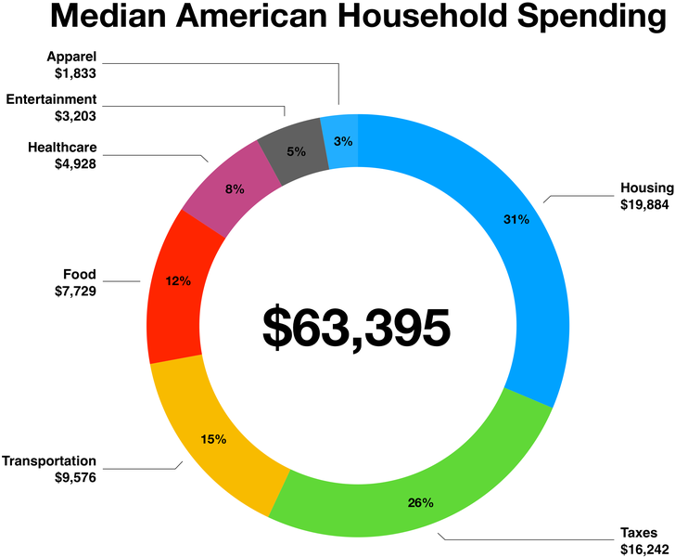
- Besides taxes, what are the three largest cost categories for families?  DOK 1 | - How much money do families spend on Entertainment?  DOK 1
- What percentage of a typical family’s expenditures would you consider needs as compared to wants?

DOK 2
- What expenses would you expect to stay the same month after month? Which would vary most month to month?

DOK 2
- You overhear a friend discuss how Americans are frivolous in their spending and waste lots of money. Use this data on family budgets to argue against his position.

DOK 3

