The Fine Print

Career #1

Learning Objectives  Students will be able to  - Understand and analyze a pay stub  Approximate Time  - Resources length: 18 mins  - Comprehension questions: 10 mins  View Google Form  - Teachers, please see the answer key to access the Google Form version of this Fine Print. | Recommended NGPF Lesson:  - 10.2 Work and Income Taxes  Jump$tart Standards  Employment & Income  - 3b: Differentiate between gross, net, and taxable income

Fine Print: Pay Stub

Getting Started:
Directions: These two resources will provide more information on the information in a paycheck stub. Follow your teacher's directions on whether you should go through these resources or skip ahead to the next section.

 | Resources | Estimated Time
1 | VIDEO (2:27)  - How to Understand Your Paycheck  - Publisher: Workforce Studios | 3 mins
2 | INTERACTIVE  - Reading a Pay Stub  - Publisher: TV411 | 15 mins

Read The Fine Print:

Directions: Use the pay stub below to analyze the information in this paycheck stub and answer the questions that follow.

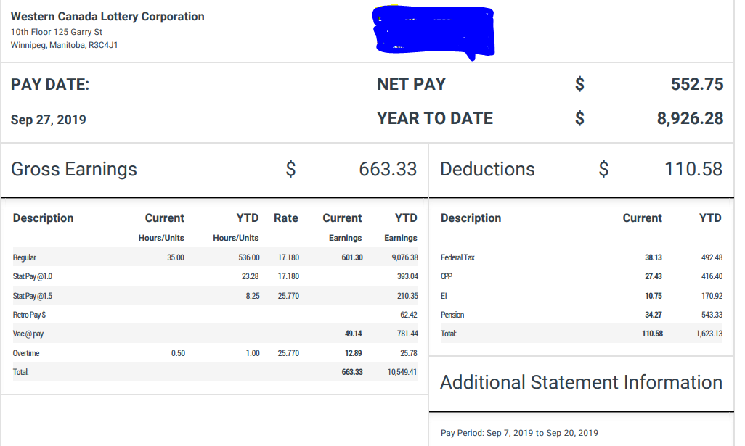

- His employer deposits her paycheck directly into his checking account. How much would his employer have deposited into Ivan's checking account on the most recent payday of 9/27/2019?
  - $40.00
  - $552.75
  - $315.21
  - $600.00

- About how frequently does Ivan receive a paycheck?
  - Daily
  - Weekly
  - Every two weeks
  - Monthly

- Which of the following statements are TRUE? (choose ALL correct answers)
Statement
Ivan actually received her pay on the last day of her pay period.
Ivan's net pay was $552.75 for this pay period.
Ivan's net pay for this pay period was $284.79.
Ivan paid $76.58 this pay period for the company pension plan provided to him by his company.

- Assuming that Ivan receives a paycheck at regular intervals similar to the stub shown, how many pay periods has Ivan had year-to-date (YTD)?
  - 2
  - 3
  - 20
  - 17

- Which of the following benefits does Ivan pay for through payroll deductions? (choose ALL correct answers, “Y” or “N”
Statement
Retirement
CPP
Pension
Employment Insurance (E.I.)

- What was the TOTAL amount deducted from Ivan's latest paycheck?
  - $90.00
  - $284.79
  - $110.58
  - $600.00

- Ivan's contribution to his Pension plan
  - is a post-tax contribution in which federal income taxes are paid
  - is pre-tax and therefore not taxed for federal income tax purposes
  - is a mandatory payroll deduction
  - is taxed at a rate of 15%

- What was the largest deduction for this pay period?
  - CPP
  - Federal Tax
  - EI
  - Retirement Pension

- One of Ivan’s coworkers quits, and during the next pay period Ivan works 60 hours instead of 40 to help cover the shifts. Which of Ivan’s deductions will definitely change as a result?
  - His Federal tax
  - His EI
  - His CPP
  - His pension
  - All of the Above

- Which of the following statements are TRUE? (choose ALL correct answers)
Statement
This is the first pay period of the year for Ivan.
Ivan's hourly pay is $40 per hour.
Ivan has contributed $543.33 to his retirement plan so far this year.
Ivan has paid $810.00 in federal taxes so far this year.

What Did You Learn?
Directions: Use what you learned from analyzing the paycheck stub to answer this question.

- What information is available on a paycheck stub?

