NGPF Activity Bank
Budgeting #27

CARTOONS: Needs vs. Wants
One of the foundations of creating a realistic budget that you can stick to is identifying what you truly need and want. While this might sound simple, it can be difficult at times to recognize the difference when you’re considering a purchase.

In this activity, you will pick one of the cartoons provided below and analyze how that cartoon depicts the struggle of identifying what is a need versus a want.

Part I: Choose a Cartoon
Select one of the cartoons provided below to analyze.

Cartoon 1

Cartoon 2

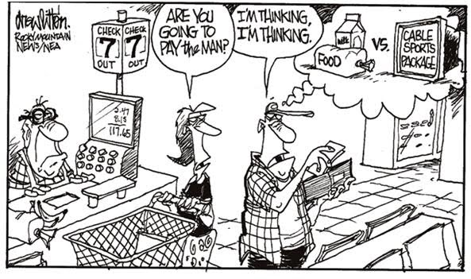

Cartoon 3

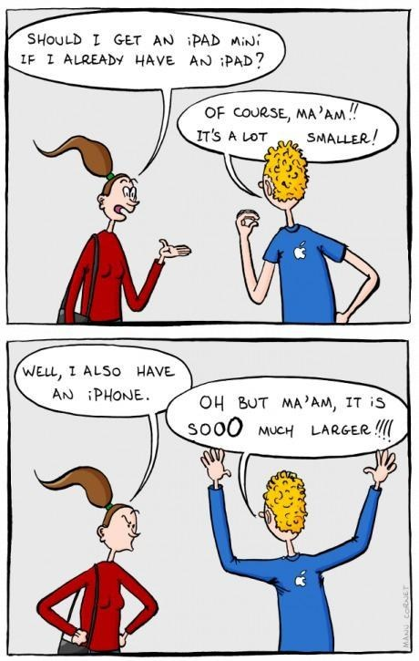

Cartoon 4

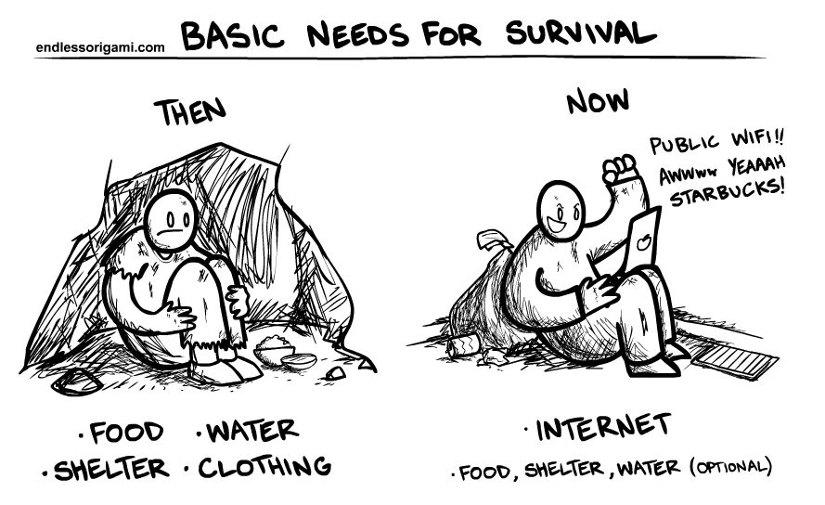

Part II: Analyze Your Cartoon
Use what you know about needs vs. wants to analyze your cartoon and answer the questions below.

- Which cartoon did you select?

- In one or two paragraphs, write an analysis of the cartoon you chose and the message it conveys about needs vs. wants. Use the questions below to guide your response:
- What message does this cartoon deliver about the struggle of identifying needs vs. wants?
- How does this cartoon portray that message?
- Did you find this cartoon persuasive? Why or why not?
- Bonus: What other techniques could the cartoonist have used to make this cartoon more persuasive?

