NGPF Activity Bank
Saving

CARTOONS: Why is it So Hard to Save Money?
Whether it’s buying that $5 coffee, a new piece of clothing that we don’t really need, or just trying to make ends meet, saving money is oftentimes easier said than done. We are often influenced by a variety of factors that make it difficult to save money. Many cartoonists have observed these challenges and wittily depict them in their cartoons.

In this activity, you will pick one of the cartoons provided below and analyze how it portrays the challenges we encounter when it comes to saving money.

Part I: Choose a Cartoon
Select one of the five cartoons provided below to analyze.

Cartoon 1
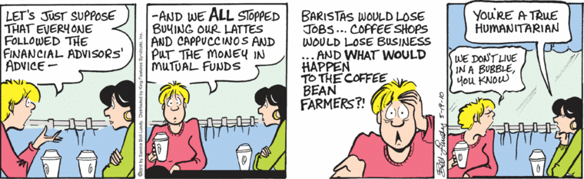

Cartoon 2
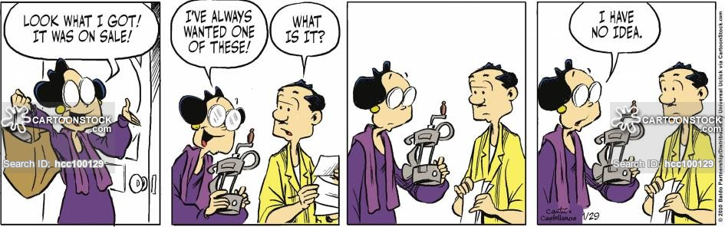
Cartoon 3

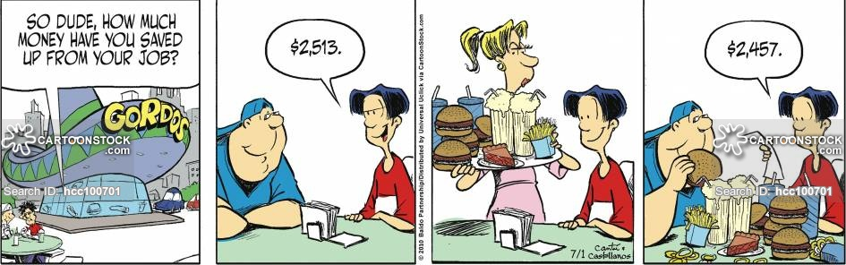

Cartoon 4  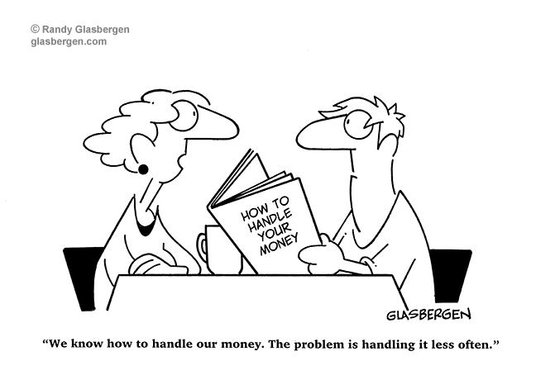 | Cartoon 5  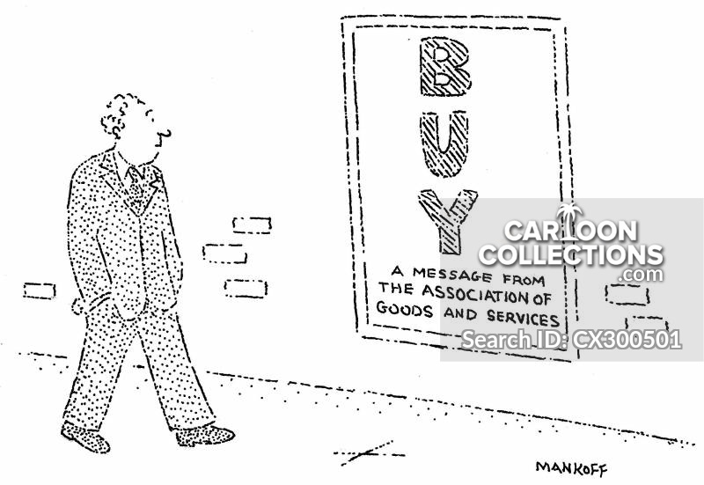

Part II: Analyze Your Cartoon
Use what you know about the challenges of saving money to analyze your cartoon and answer the questions below.

- Which cartoon did you select?

- In one or two paragraphs, write an analysis of the cartoon you chose and the message it conveys about why it can be difficult to save money. Use the questions below to guide your response:
- What is the main challenge this cartoon delivers about why it can be difficult to save money?
- How does this cartoon portray that message?
- Did you find this cartoon persuasive? Why or why not?
- Bonus: What other techniques could the cartoonist have used to make this cartoon more persuasive?

