Chapter 7 Quick Review
1. The term ____________ refers to a market exchange that affects a third party who is outside or external to the exchange.
A. social costs
B. spillover
C. market failure
D. private costs
2. Using the term "spillover" is a less formal means of describing
A. an externality.
B. social costs.
C. private costs.
D. market failure.
3. ____________________ describes a situation where a third party, outside the transaction, suffers from a market transaction by others.
A. Negative externality
B. Positive externality
C. A spillover
D. A market failure
4. A positive externality arises in a situation where a third party, outside the transaction,
A. fails to allocate resources efficiently.
B. suffers from a market transaction by others.
C. benefits from a market transaction by others.
D. pays a pollution tax to balance social costs.

5. _______________ include both the private costs incurred by firms and also costs incurred by third parties outside the production process.
A. Social costs
B. Private costs
C. Market costs
D. External costs
6. Market failure describes a situation in which the market itself ______________________ in a way that balances social costs and benefits.
A. remains outside the transaction
B. incurs the costs outside the production process
C. fails to allocate resources efficiently
D. avoids externalities
7. The problem of pollution typically arises in ______________ economies around the world.
A. high-income
B. low-income
C. high or low-income
D. middle income
8. Which of the following would be classified as a situation where a third party benefits from a market transaction by others?
A. City buying 10,000 trees for green space renewal projects.
B. Increased levels of air pollution in neighborhoods near a football stadium.
C. Allowing a mining company to use a natural lake to discharge waste.
D. Two firms trading pollution credits to avoid cutting their toxic emissions.
9. A beekeeper decides to locate her business on a plot of land that is between an apple orchard and an elementary school. A negative externality that can result is
A. the cost of the bee hives to the beekeeper.
B. the possibility of the bees stinging the students at the school.
C. the bees helping to pollinate the orchard, leading to more fruit.
D. the honey the bees produce.
10. A beekeeper decides to locate her business on a plot of land that is between an apple orchard and an elementary school. A positive externality that can result is
A. the cost of the bee hives to the beekeeper.
B. the possibility of the bees stinging the students at the school.
C. the bees helping to pollinate the orchard, leading to more fruit.
D. the honey the bees produce.
13. When reference is made to the ____________, it means the specific amount of income needed for a basic standard of living.
A. poverty trap
B. income line
C. income gap
D. poverty line

14. A situation of __________ arises when one group receives a higher share of total income or wealth than others.
A. poverty
B. inequality
C. poverty entrapment
D. quintiles
15. A method often used by economists to look at distribution of income in a society's economy involves
A. programs for wealth redistribution.
B. quintiles, or dividing a whole group into fifths.
C. imposing taxes to redistribute wealth.
D. quads, or dividing a whole group into fourths.
16. A Lorenz curve refers to a graphic illustration of the share of population on the _______________ and the cumulative percentage of total income received on the __________________ .
A. left quintile; right quintile
B. right quintile; left quintile
C. horizontal axis; vertical axis
D. vertical axis; horizontal axis
21. A Lorenz curve graphs the _________________ received by everyone up to a certain quintile.
A. unequal distribution over time
B. normative shares of income
C. cumulative shares of income
D. total share of income
22. Every Lorenz curve diagram begins with a line __________________ .
A. sloping down at a 45-degree angle
B. sloping up at a 45-degree angle
C. upward sloping U-shape
D. downward sloping hump shape
34. | The most important determinant of labour income is:
 | A) | education
 | B) | experience
 | C) | working conditions
 | D) | productivity

35. | Data on education and earnings reveal:
 | A) | no relationship between the two
 | B) | an inverse relationship between the two since, as individuals age, productivity falls
 | C) | a direct relationship between the two
 | D) | an inverse relationship between the two

37. | Job discrimination occurs when:
 | A) | a worker is hired, paid, or promoted based on aspects other than credentials or performance
 | B) | a worker is promoted based on skill
 | C) | workers receive equal pay for providing identical services
 | D) | equilibrium is affected by shifts in labour supply
38. | Which of the following plays a role in causing poverty?  - the lazy nature of the working poor  - increasing numbers of multinational corporations  - the growth of the public sector in a country  - which region a Canadian lives in

1. You’d be willing to pay $200 for a daylong admission ticket to a theme park. The cost of the ticket is $120. Your consumer surplus is: *
a. $0
b. $80
c. $120
d. $320
2. A limited edition package is sold only to 200 customers for $130 each. The average value of the package for the 200 customers is $280. What is the total consumer surplus? *
a. $150
b. $15,000
c. $30,000
d. $150,000
3. What should we expect to happen if the consumer surplus of a trade is negative? *
a. The consumer gains no value from the trade.
b. The consumer loses value from the trade.
c. The consumer’s gain from trade is the absolute value of the consumer surplus.
d. The trade does not happen.

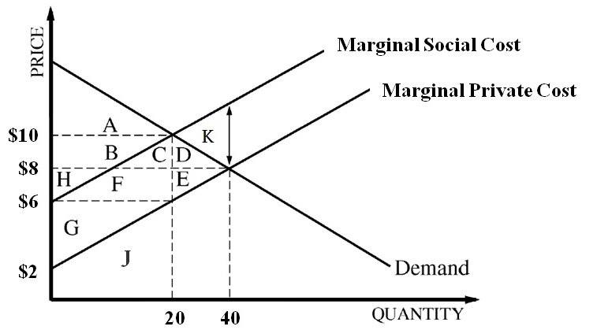

- Refer to the graph above, which depicts (shows) the market for Sun-LessTM, a popular spray tanning product. Sun-LessTM currently produces costs to individuals who are neither consumers nor producers in the form of a peculiar (strange) odor (smell) that lingers (stays) for days after the product has been applied. The letters in the graph represent the enclosed areas. Prior to (before) any government action, which of the following correctly states the price, quantity, and deadweight loss (if any exists)?

Price Quantity Deadweight Loss
- $10 20 DE
- $10 20 K
- $8 40 DE
- $8 40 K

