NGPF Activity Bank

Types of Credit #10
Spanish Version

COMPARE: Auto Loans
Molly is celebrating her exciting new career and wants to upgrade her junky old car for a shiny new Jeep Patriot. She heads to Jeep’s website and sees the following financing deals:

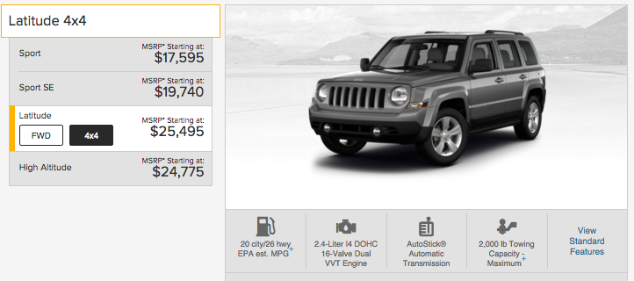
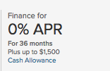 | 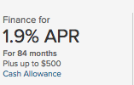 | Note: For this activity, assume Molly’s going to pay the exact MSRP of $25,495. This is most likely NOT true, but we’ll use it for simplicity.

Part I: 0% APR sounds PERFECT!
Answer the following questions using the details from the 0% APR offer above. Please round all answers to the nearest dollar.

- Molly has a $2500 down payment saved for this purchase, and the dealer’s $1500 Cash Allowance will come straight off her total. How much loan does Molly need?

- How much will Molly’s monthly payment be?

- How much total interest will Molly pay using this plan?

- When Molly adds all of her payments, how much will the car cost her?

Part II: Maybe the 1.9% is more manageable?
Oh, boy! Look at that monthly payment from Question 2 above! Molly cannot afford the monthly payment using the 0% financing. She opens up Bankrate’s Loan Calculator to see how much she’d pay with the other financing option.

- Remember that Molly has a $2500 down payment saved for this purchase. The dealer will take the $500 Cash Allowance straight off her total. How much loan does Molly need?

- Using the Loan Calculator and the 1.9% APR offer, how much will Molly’s monthly payment be?

- How much total interest will Molly pay using this plan?

- When Molly adds all of her payments, how much will the car cost her using this plan?

Part III: Reading the Fine Print
Excited to buy her dream car, Molly rushes into her local Jeep dealership. Molly picks out a car, sits down at the financing desk, and hears the following:

“Well, we ran your credit history. You’ve got a really thin file -- just a year’s worth of student loan payments. The deal you saw was for ‘well qualified buyers.’ The best deal we can offer you is 6.6% for 60 months. A little more bad news -- the cash allowance is also based on credit history, so you don’t qualify for $500. That said, you’re excited about a Jeep, and I want to see you driving one, so I can do $400 for you!”

- Molly still has a $2500 down payment. How much loan does Molly need?

- How much will Molly’s monthly payment be using the Bankrate calculator?

- How much total interest will Molly pay using this plan?

- When Molly adds all of her payments, how much will the car cost her?

Part IV: In Summary
- What valuable lessons did Molly learn about auto financing?

- Molly desperately wants a Jeep Patriot, and this new monthly payment is pretty high again. What suggestions do you have for making her dream become reality?

