NGPF Activity Bank

Types of Credit

Fine Print: Auto Title Loan Agreement

- Teacher Tip: If you prefer to administer this activity using a Google Form, please see the answer key for the Google form link. You can find this on the Unit Page this resource is in.

In this activity, you will explore an auto title loan agreement in more detail to understand its various components. Then, you will answer questions using the sample auto title loan agreement below.

Part I: Read The Fine Print

Analyze this sample auto title loan agreement and answer the questions that follow.

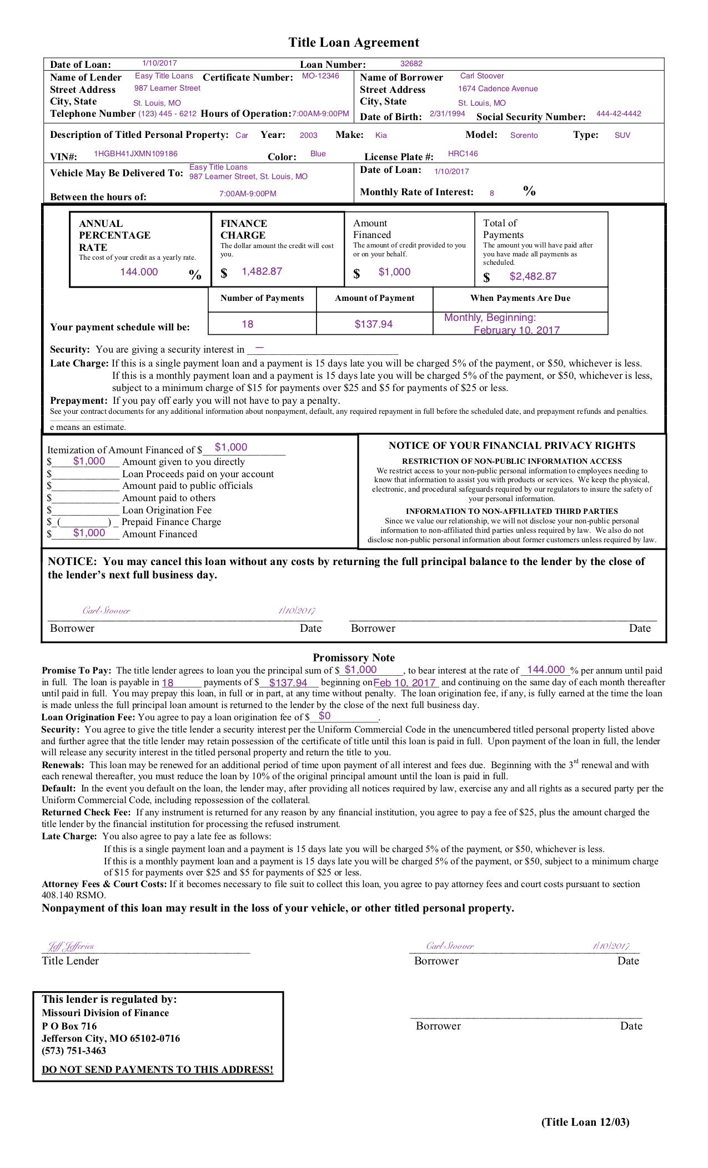

- What kind of car is Carl offering as collateral in exchange for his auto title loan?
  - 1987 Honda Accord
  - 1999 Subaru Legacy
  - 2001 Toyota Rav4
  - 2003 Kia Sorento

- What is the amount financed to Carl Stoover for this title loan?
  - $137.94
  - $1,000
  - $1,482.87
  - $2,482.87

- What kind of auto title loan did Carl agree to?
  - Single payment after one month
  - Interest-only payments for one-month period
  - One-year installment plan
  - 18-month installment plan

- According to this contract’s schedule, when will Carl pay off his auto title loan?
  - February 10, 2017
  - July 10, 2017
  - February 10, 2018
  - July 10, 2018

- How are Carl's monthly and annual interest rate charges related?
  - The two rates are not related. Carl will be charged an annual interest fee AND a monthly interest fee.
  - The APR of 144% is distributed over 18 months (8% per month).
  - The two rates are not related, but Carl can then select which rate is better for him.
  - The APR of 18% is distributed over 8 months (144% per month).

- What does the $1,482.87 finance charge represent?
  - The cost of borrowing the money for this title loan
  - The amount of loan money provided
  - The total payment for the loan
  - The cost of insurance for the car

- How much does Carl owe on each repayment date?
  - $137.94
  - $1,000.00
  - $1,482.87
  - $2,482.87

- The first payment is due _________ after this agreement was made.
  - 12 days
  - 2 weeks
  - 1 month
  - 6 months

- What will happen if Carl is 20 days late on a payment for his monthly loan?
  - He would have to pay a $50 late fee charge
  - The auto title loan agreement would become void
  - He would have to pay a $15 late fee charge
  - He would have to pay a $25 late fee charge

- If Carl defaults on the loan, what could happen?
  - The car will be held in storage for a month, then given back to Carl.
  - The car may be repossessed and become property of the lender.
  - The car will be sold to another borrower in one week.
  - The car will be given back to Carl immediately, but he has to give up his driver’s license.

Part II: What Did You Learn?
Use what you learned from analyzing the auto title loan agreement to answer this question.

- Using information from the auto title loan agreement, explain why an auto title loan might be a poor choice for improving one’s finances.

