NGPF Activity Bank

Checking

FINE PRINT: Checking Account Statement

- Teacher Tip: If you prefer to administer this activity using a Google Form, please see the answer key for the Google form link. You can find this on the Unit Page this resource is in.

In this activity, you will explore a checking account statement in more detail to understand its various components. Then, you will answer questions using the sample statement below.

Part I: Read The Fine Print

Analyze this sample checking account statement and answer the questions that follow.

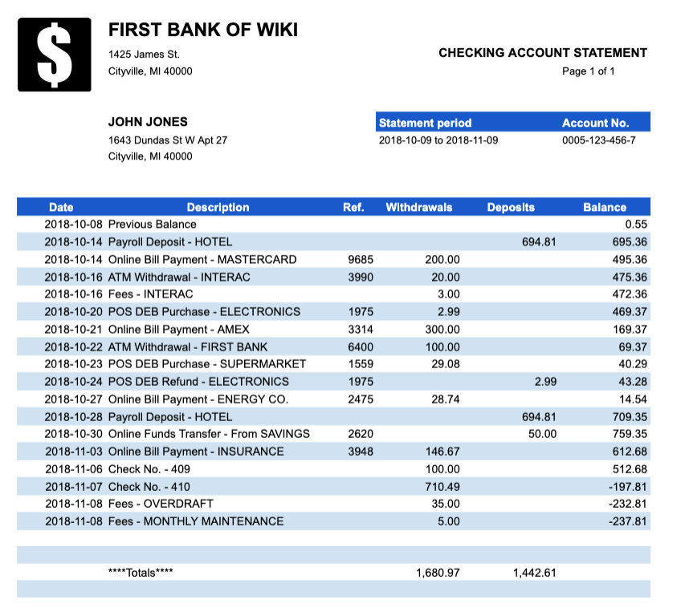

- How frequently does John typically receive account statements from his bank?
  - Daily
  - Weekly
  - Monthly
  - Annually

- How much did John Jones have in his account on the first day of the statement period?
  - -$72.47
  - $0.55
  - $694.81
  - $1,442.61

- John has two ATM transactions but only one of them has a fee (Interac). Why?
  - Interac is an out-of-network ATM and First Bank charges customers if they use out-of-network ATMs.
  - First Bank charges customers for using their ATMs.
  - Banks charge fees if you take out less than $100 at an ATM machine.
  - The first ATM transaction is free but all additional ATM transactions have a fee.

- Most employers will pay their employees by directly depositing their paycheck into their checking account. According to his checking account statement, John was paid ________________ every __________ .
- $200.00, 3 weeks
- $694.81, 2 weeks
- $300.00, 1 month
- $100.00, 2 weeks

- What is the impact of the Online Funds Transfer - From Savings that appears on John's statement?
  - John's Savings account balance declined by $50 and his Checking account balance increased by $50
  - John's Savings account balance increased by $50 and his Checking account balance declined by $50
  - John's Savings account balance had no change and his Checking account balance declined by $50
  - John's Savings account balance increased by $50 and his Checking account balance had no change

- Which statement is true regarding Check No. - 409?
  - This check likely came from John’s employer.
  - This check was written by John and paid to another person or business.
  - This check caused John to overdraw his checking account.
  - This check added $100 to John’s account.

- Which transaction caused John to overdraw his account?
  - The Online Bill Payment for $146.67
  - Check No. 409 for $100
  - Check No. 410 for $710.49
  - The Overdraft Fee of $35

- What was the result of John overdrawing his checking account?
  - John’s payment was greater than the balance he had available in his account so the bank will deposit $237.81 into John’s account so he can pay his bills.
  - John’s payment was greater than the balance he had available in his account so he was charged a $35 fee.
  - John’s payment was greater than the balance he had available in his account so he was charged a $5 monthly maintenance fee.
  - John’s payment was greater than the balance he had available in his account so the bank will transfer $35 from a linked account.

- Which fees was John charged on his checking account during this statement period?
  - Online Transfer Fee, Overdraft Fee, Per Check Fee
  - Per Check Fee, ATM Fee, Overdraft Fee, Maintenance Fee
  - Online Transfer Fee, ATM Fee, Maintenance Fee
  - ATM Fee, Overdraft Fee, Maintenance Fee

- What is the mathematical formula that you would use to describe the financial activity on a bank statement?
  - Ending Balance = Previous Balance + Deposits + Withdrawals
  - Ending Balance = Previous Balance - Deposits + Withdrawals
  - Ending Balance = Previous Balance + Deposits - Withdrawals
  - Ending Balance = Previous Balance - Deposits - Withdrawals

Part II: What Did You Learn?
Use what you learned from analyzing the checking account statement to answer this question.

- Why is it important to review your checking account statement? What fees might this help you avoid? Explain your answer.

