NGPF Activity Bank

Types of Credit
Teacher Tip Video

FINE PRINT: Credit Card Statement

In this activity, you will explore a credit card statement in more detail to understand its various components. Then, you will answer questions using the sample credit card statement below.

Part I: Read The Fine Print
Analyze this sample credit card statement and answer the questions that follow.
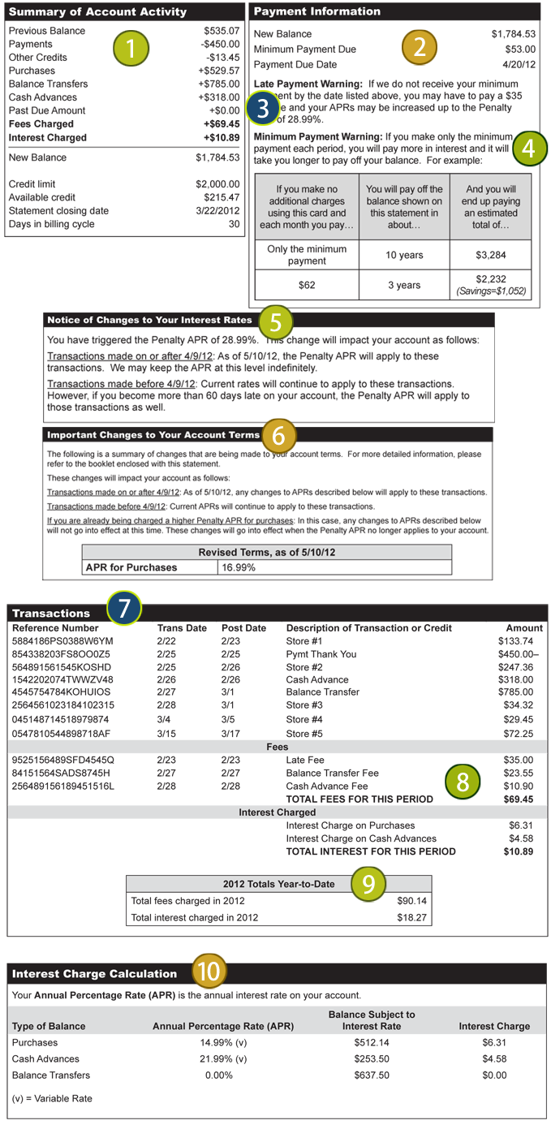

- In reviewing your Summary Account Activity (#1), you notice FEES CHARGED of $69.45. This fee was assessed on your account for the following reasons EXCEPT…
  - Late Payment Fee
  - Balance Transfer Fee
  - Cash Advance Fee
  - Annual Fee

- How much do you currently owe on this credit card?
  - $535.07
  - $785.00
  - $529.57
  - $1,784.53

- Which of these transaction types DECREASE how much you owe the credit card company?
  - Balance Transfers
  - Cash Advances
  - Payments
  - Interest Charged

- Before sending in your payment to the credit card company, you go to a bicycle store. Approximately, how much can you spend before going over the credit limit on your card?
- $0, you are already over your credit limit
- $200
- $500
- $2000

- A general rule of thumb is to keep your credit utilization rate at 30% or lower. What is your approximate credit utilization rate for this current billing cycle? (Hint: Credit Utilization Rate = Balance / Credit Limit)
  - 30%
  - 50%
  - 70%
  - 90%

- Which of the following statements is FALSE?
  - If you pay the MINIMUM PAYMENT of $53.00, you will not have to pay interest for the balance you still owe.
  - If you pay only the minimum payment AND DO NOT make any additional charges on your card it will take you 10 years to pay off your card.
  - If you pay $9.00 more than your minimum payment of $53.00 (or $62.00), you will reduce the time to pay off your credit card debt to three years.
  - If you want to pay off your credit card debt faster you should pay more than the minimum payment every month.

- The statement says that you’ve triggered the Penalty APR so that it has now increased to 28.99%. What action triggered this?
- You paid your last bill online in full by the due date.
- You paid only the minimum payment by the due date.
- You failed to pay the minimum payment by the due date.
- You failed to pay your late payment fee.

- At the Penalty APR rate of 28.99% and a balance of about $1800, approximately how much interest would you owe in one month?
- $30
- $40
- $60
- $100

- You were charged interest of $6.31 for Purchases (near section 8). Why?
  - You paid off your entire balance from the month before.
  - You had a balance of $535.07 from the previous month and only paid $450.00 so you didn’t pay off your balance in full.
  - You borrowed more than your credit limit and were charged interest on the amount you borrowed over your limit.
  - The credit card company paid you interest for the purchases you made on their credit card.

- It is April 19, 2012 and you suddenly remember that your credit card bill is due the next day. You have the money in your checking account to pay the bill in full. The mailing address for the credit card company is a few thousand miles away so you assume that it will take a few days for your check to arrive. What should you do?
  - Take the letter to the post office to get it postmarked on or before April 20th since that will be fine with the credit card company.
  - Access your credit card account online to see if they have online options available that will get the payment to them by April 20th.
  - Send the check to your credit card company through your bank’s bill pay service which guarantees 48 hour delivery.
  - Call the credit card company to tell them you will be late with your payment.

Part II: What Did You Learn?
Use what you learned from analyzing the credit card statement to answer this question.

- Your friend, Caitlyn, does not think it is important to review her monthly credit card statement. Instead, she just sets up an automatic minimum payment on the 18th of each month. Convince Caitlyn that this is a bad idea.

