NGPF Activity Bank

Types of Credit

FINE PRINT: Mortgage Bill

- Teacher Tip: If you prefer to administer this activity using a Google Form, please see the answer key for the Google form link. You can find this on the Unit Page this resource is in.

In this activity, you will explore a mortgage bill in more detail to understand its various components. Then, you will answer questions using the sample mortgage bill below.

Part I: Read The Fine Print

Analyze this sample mortgage bill and answer the questions that follow.

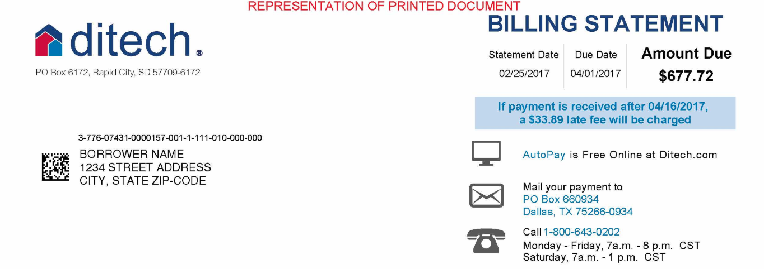
[bill continues on next page]
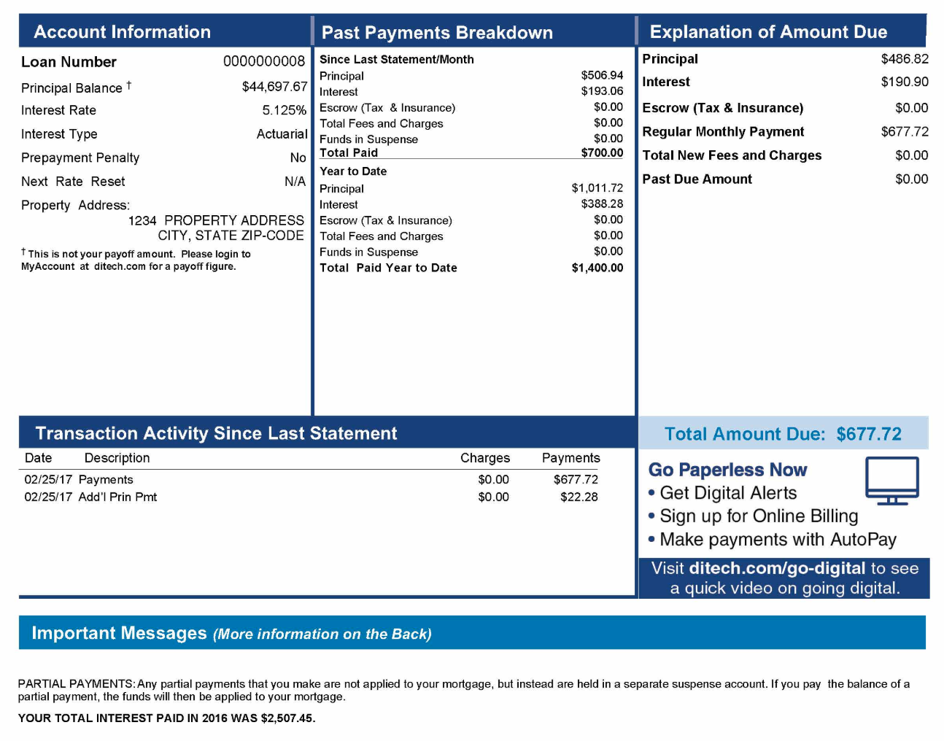
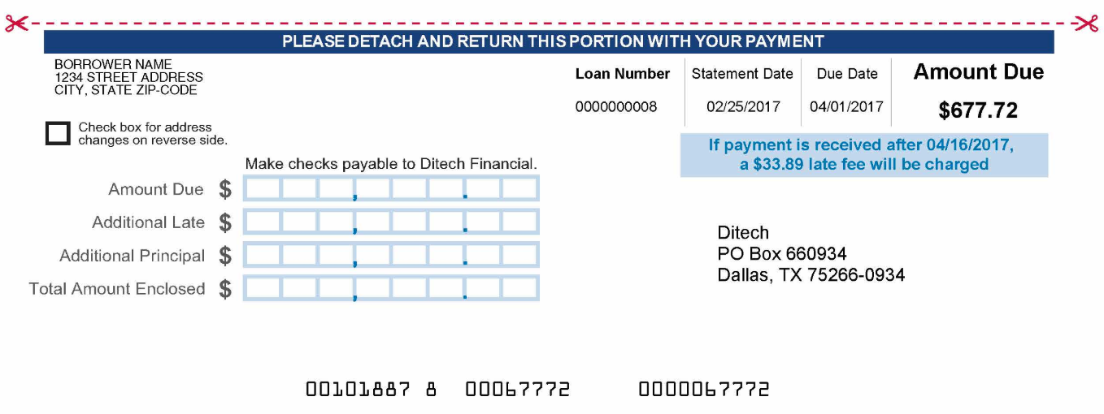

[questions on next page]

- Who is the mortgage servicer on this mortgage statement?
  - It’s not listed -- it just says “BORROWER NAME”
  - Ditech Financial
  - Rapid City, SD
  - It’s not listed -- it just says “CITY, STATE ZIP-CODE”

- What is the amount due on this month’s mortgage billing statement?
  - $190.90
  - $486.82
  - $677.72
  - $44,697.67

- Which statement about the due date is most accurate?
  - Payment is due 2/25/2017, but the servicer won’t charge a fee unless they pay after 4/1/2017
  - Payment is due 4/1/2017, and there is no fee if they pay late
  - Payment is due 4/1/2017, and the servicer will charge a fee if they pay after that date
  - Payment is due 4/1/2017, but the servicer won’t charge a fee unless they pay after 4/16/2017

- How much of the original principal balance does the borrower still owe?
  - $486.82
  - $677.72
  - $1,400.00
  - $44,697.67

- What interest rate is the borrower paying on this mortgage?
  - You cannot tell from this bill
  - 5.125%, and it is not scheduled to change
  - 5.125%, but it changes every month
  - 190%

- How much money has the borrower paid this year on the mortgage?
- $506.94
- $677.72
- $700.00
- $1400.00

- What are the borrower’s options for how they can pay this mortgage bill?
  - It must be paid by check
  - It must be paid in cash
  - It must be paid online on the ditech website
  - It can be paid by check or online on the servicer website

- Early in a mortgage repayment schedule, most of the payment goes toward interest and a tiny bit goes toward principal. As months go on, the interest and principal payments even out. Then, late in the mortgage schedule, most of the payment goes toward principal and a smaller bit goes toward interest, until the entire bill is paid off. Knowing that, where is this borrower in their mortgage repayment schedule?
  - They have just started paying their mortgage this year
  - They are early in their mortgage repayment plan
  - They are late in their mortgage repayment plan
  - You cannot tell from this mortgage statement

- How much has this borrower been charged in fees?
  - $0
  - $22.28
  - $190.90
  - $677.72

- Which statement best describes the payment the borrower made last month?
  - The borrower paid less than the minimum amount due
  - The borrower paid exactly the minimum amount due
  - The borrower paid more than the minimum amount due
  - The borrower paid off the entire mortgage

Part II: What Did You Learn?
Use what you learned from analyzing the mortgage bill to answer this question.

- List three pieces of information listed in a mortgage bill that you believe are important to review when receiving the statement. Explain why you chose these three areas.

