NGPF Activity Bank

Types of Credit

FINE PRINT: Schumer Box

In this activity, you will explore a credit card agreement, called a Schumer Box, in more detail to understand its various components. Then, you will answer questions using the sample Schumer Box below.

Part I: Read The Fine Print

Analyze this sample Schumer Box and answer the questions that follow.

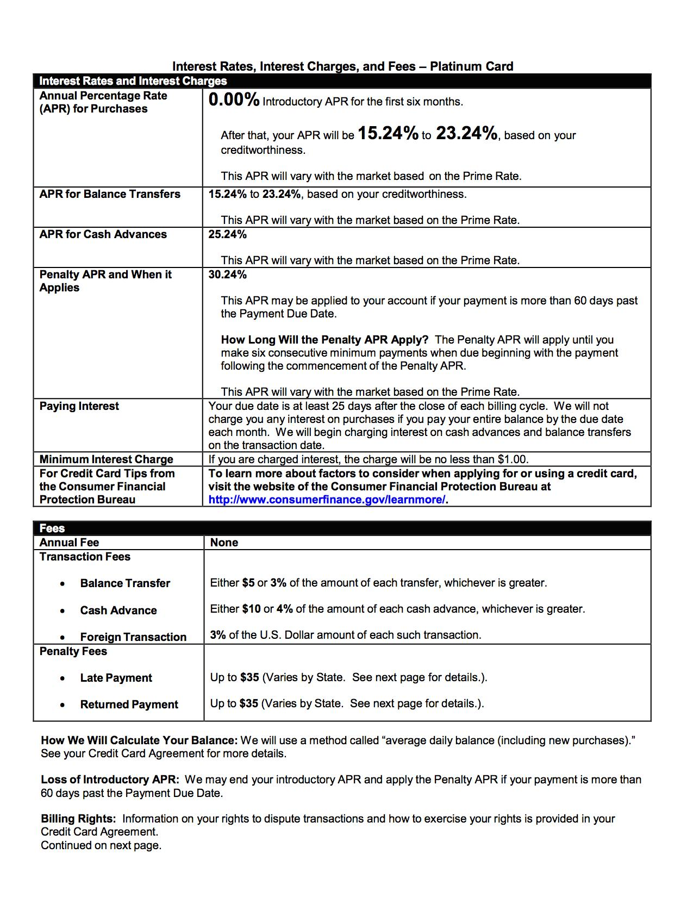

Continues on Next Page

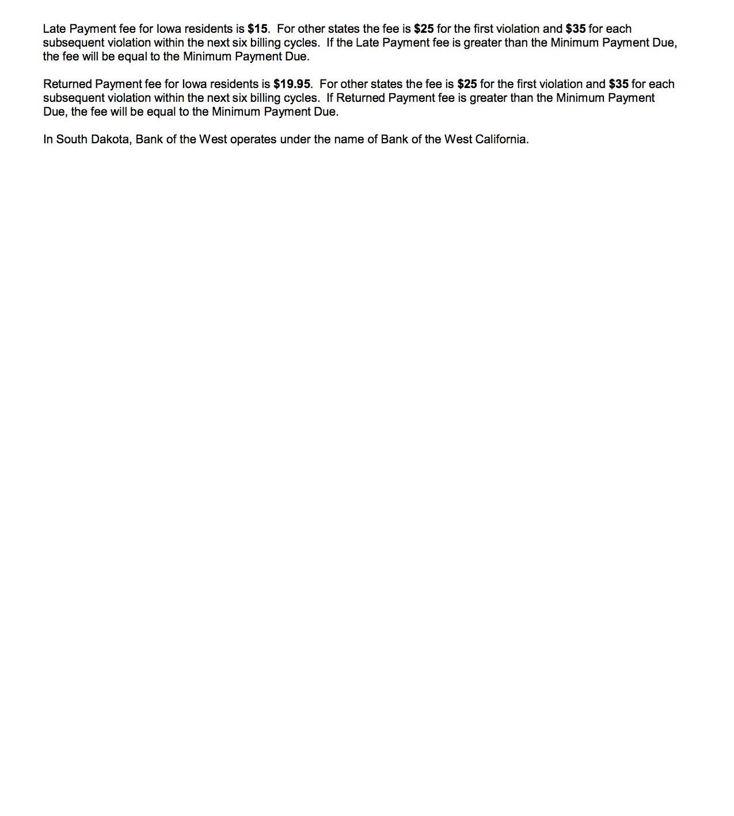

- What is the APR (interest rate) on this card for Purchases made during the first six months that a cardholder has this card?
  - 0%
  - 15.24%
  - 23.24%
  - 25.24%

- Jordan gets confused and uses his credit card to get $40 in cash from an ATM instead of using his debit card. Based on this agreement, what is the impact of this decision?
  - There is no impact since credit card and debit card terms tend to be the same.
  - A $10 cash advance fee will be charged ONLY.
  - An A.P.R. of 25.24% will be applied on the $40 until it is paid back ONLY.
  - A $10 cash advance fee will be charged AND an A.P.R. of 25.24% will be applied on the $40 until it is paid back.

- Assume that Louisa carried an average balance of $1,000 from her credit card purchases over the past year. The A.P.R. on her credit card for the past year was 19.99%. Approximately how much interest would Louisa have paid over the course of the year?
  - She would have paid interest charges of $2,000.
  - She would have paid interest charges of $20.
  - The credit card company would have paid Louisa $20.
  - She would have paid interest charges of $200.

- After the introductory period, all consumers who have this Platinum Card will...
  - Pay the same A.P.R.
  - Qualify for an A.P.R. based on their creditworthiness
  - Pay the Penalty A.P.R. of 30.24%
  - Be charged an Annual Fee

- As you will see from this agreement, there are different A.P.R.s applied based on how the credit card is used. Which transaction type has the highest A.P.R.?
- A.P.R. triggered by a late payment
- A.P.R. applied on Purchases made during the Introductory Period
- A.P.R. applied to a Balance Transfer
- A.P.R. applied to a Cash Advance

- Devon forgets to pay his credit card bill for three months. Which of the following statements is TRUE?
  - A Late Payment fee will not be charged to his account.
  - A Balance Transfer fee will be charged to his account.
  - His A.P.R. (interest rate) will rise to 30.24% until he pays back the amount he owes.
  - His A.P.R. (interest rate) will rise to 30.24% and stay there until he makes six consecutive minimum payments.

- Tamara goes on a spring break trip with her school to visit historical sites in Italy. She purchases $200 of souvenirs while on the trip. She gets back to the U.S. and opens her credit card statement. What will be the balance in her account, assuming she had a zero balance prior to making these purchases and didn't make any other purchases?
  - $0.00
  - $200.00
  - $206.00
  - $6.00

- All of the following actions lead to the payment of a credit card fee EXCEPT...
  - Using your credit card to get cash from an ATM.
  - Using your credit card to purchase items in a foreign country.
  - Paying your credit card bill ten days after the Due Date.
  - Paying your credit card bill in full and on time every month.

- Josephine decided to get this Platinum card since she saw the ads touting the "0% A.P.R. Platinum. Sign Up Now." After reading this agreement, which of the following statements is TRUE?
  - Her A.P.R will change after six months and be between 15.24% to 23.24% assuming that she has been making on-time payments during those first six months.
  - She will not pay interest on any of the purchases she makes on this credit card for the first year.
  - All her purchases on this credit card are FREE for the first six months.
  - All her purchases on this card are FREE.

- Which of the following statements is TRUE?
  - Assume that Josie has had this credit card for a year. The A.P.R. on her card will remain the same as long as she has the card.
  - If Josie misses a payment during the Introductory Period, her late payment fee will be waived for this period since she is a new customer.
  - Assume that Josie only uses her credit card to make purchases. She pays the balance on her credit card in full and on time every month. As a result, she pays no interest to the credit card company.
  - Josie pays an annual fee to use this credit card.

Part II: What Did You Learn?
Use what you learned from analyzing the credit card agreement to answer this question.

- List three pieces of information listed in a credit card agreement that you believe are important to review before signing up for a credit card. Explain why you chose these three areas/fees.

