Financial Literacy 21G
Name:

Forms of Money
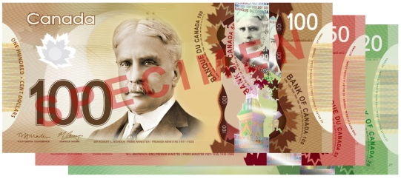
PART A: Bank Notes (20 points)
Use the following link (http://www.bankofcanada.ca/banknotes/) to answer the questions below:

- Who designs Canada’s bank notes? (1)

- Why did they switch from paper to the new polymer material? Provide at least two different reasons in your answer please. (2)

- What is counterfeiting? Is this good or bad for our economy? Explain your answer. (3)

- Why are our bank notes different colours? (1)

- Complete the following chart on the five denominations of bank notes produced in Canada (use the latest issue of the polymer bills): (5)

Denomination | Colour | Front Image | Back Image
$5
$10
$20
$50
$100

Use the following link (http://www.mint.ca/store/mint/learn/history-timeline-4000020) to answer the questions below:

- In what year was the first coin produced in Canada? (1)

- In what year was the loonie first introduced? Why did they create this to replace the $1 bank note? (2)

- The Canadian Mint is a world leader when it comes to patented technology. What is a patent? (1) Name one technology patent our Mint owns. (1)

- When did the Canadian Mint stop circulating the penny? (1) Why? (1)

- What will happen to cash transactions now that the penny is out of circulation? (1)

PART C: Debit Cards (6 points)
Answer the following questions related to debit cards:

- Explain why debit cards are called debit cards. (1)

- List at least two things you can do to protect yourself against debit card fraud. (2)

- Is there a cost to withdraw money from an Automated Banking Machine (ABM)? Explain. (2)

- Name one thing the banking industry is trying to do in order to make debit cards more secure. (1)

