NGPF Activity Bank

Investing

INTERACTIVE: Beat the Market on Tech IPOs

Interactive: LA Times Beat the Market on Tech IPOs

You might have heard about companies announcing an IPO and seen the excitement and buzz that is generated around these events. But, what exactly does it mean for a company when it has an IPO? And how does this relate to you as an investor? In this activity, we’ll be answering these questions by playing an interactive from the LA Times!

Part I: What is an IPO?
Let’s first take a look at what an IPO is and why it generates the excitement it does. Use this Investopedia article on IPOs (or do your own research) to answer the following questions.

- In your own words, explain what an IPO is and why it can be exciting.

- As an investor, would you want to buy shares of a company on the very first day of its IPO? Or would you want to wait a while? Explain your reasoning.

Part II: Become a Tech Investor
It’s time to become an investor by playing the LA Times’ Interactive! In this interactive, you’ll be deciding when to buy the shares of seven companies that have announced an IPO.

A few things to remember as you play:
- Be sure to fill out the table in question 3 after each round so you can capture the information you’ll need.
- Remember the cardinal rule of investing: Buy LOW and sell HIGH. In this interactive, you are ONLY choosing when to BUY, which means you’re trying to get the LOWEST price possible. Good luck!

- For each company, record the price YOU bought a share at as well as the Best Price (the lowest price). The interactive will give you these values after each round.

Company (ticker) | IPO Close-of-Day Price | Your Price | Best (lowest) Price
Snap (SNAP) | $24.00
Facebook (FB) | $42.05
LinkedIn (LNKD) | $83.00
Twitter (TWTR) | $45.10
Pandora (P) | $20.00
Workday (WDAY) | $48.05
GoPro (GPRO) | $28.65

- How many times did your share purchase price “beat” the IPO price?

- For which company did you get closest to the Best Price? How close were you?

- Would you describe your stock purchases as a success? Why or why not?

Part III: Now, Let’s Sell
It’s been a while since you bought your shares and you’ve decided to sell them today. Remember, you can make money in the stock market through dividends AND by selling your shares at a price higher than what you paid. Use Yahoo! Finance to look up the current stock price for each of these tech companies, and then calculate your ROI (return on investment) using the formula below.

Note: Since the time this interactive was created, LinkedIn and Pandora were acquired by other companies, so we will be skipping these two companies in our calculations below.

$$ROI = \frac{Today's Price - Your Price}{Your Price}x 100$$

- Record Your Price, Today’s Price, and your ROI for each company.

Company (ticker) | Today’s Price | Your Price | ROI  (Return on Investment)
Snap (SNAP)
Facebook (FB)
Twitter (TWTR)
Workday (WDAY)
GoPro (GPRO)

- Based on the ROI for the shares above, would you describe your stock purchases as a success? Why or why not?

Part IV: Help a Friend

- You and your best friend have the following text exchange. What advice would you give your friend on investing in Crabtree’s IPO? Why?
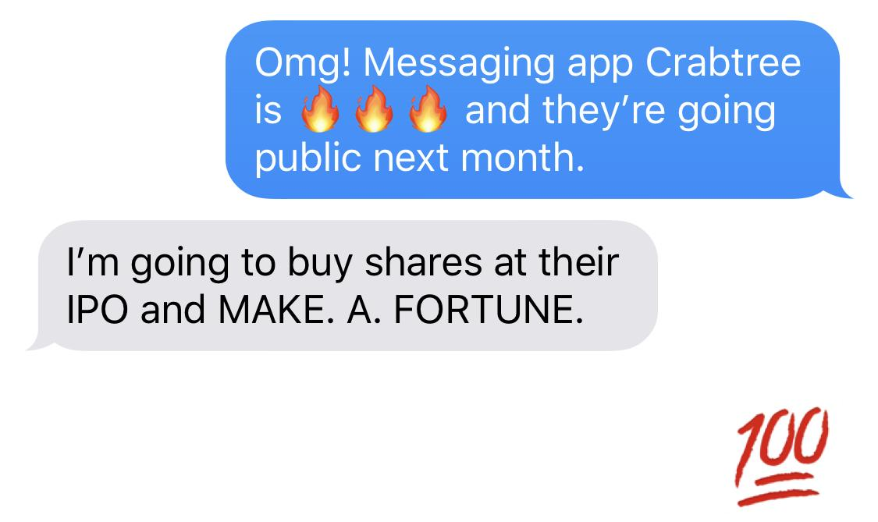

Note that the current stock price is the large price directly underneath the company name and ticker symbol.

