NGPF Activity Bank
Insurance

INTERACTIVE: Bummer!

Interactive: Bummer!

Part I: Play Bummer!
- Go to www.thebummergame.com and play Bummer!
- As you play the game, pay attention to how your insurance choices and the outcomes of the Wheel of Bummers impact Your Total Money. If you want, you can jot down any notes from the game here.

Part II: Reflection Questions
- Bummer! has 4 rounds - pet, rental, auto, and then all 3 combined.
  - How many rounds did you make it through before running out of money? Or, did you win the game?

  - What factors did you consider before deciding on a plan? How did you decide which plan was the best value?

  - If you played again, what would you do differently? Why?

- Generally speaking, what was the relationship between the premiums, deductibles, and coverage limits for your insurance coverage?

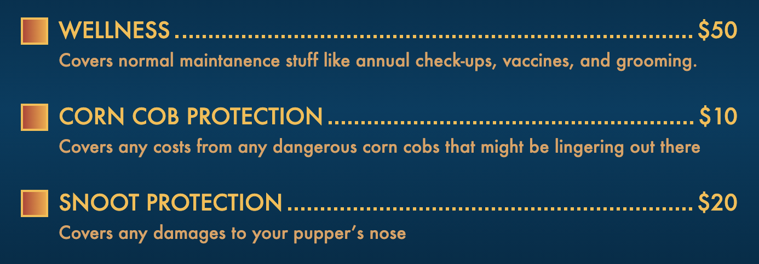

- After buying your basic coverage, the game offered you extra coverage referred to as Add Ons. In real life they’re called riders or endorsements. What strategies did you use to determine if a rider was worth the additional premium cost per month?

- In the game, you’re forced to buy at least minimal coverage for each of three insurance types -- pet, rental, and auto.
  - In real life, if your monthly budget was tight, what insurance type(s) would you cut? Why?

  - What would be the risk of reducing or eliminating coverage?

- The purpose of insurance is to provide you with financial protection against a possible risk. In Bummer!, risk is generated by the Wheel of Bummers. Describe how you felt each time you spun the Wheel of Bummers, both when you had plenty of money and when you were short on cash.

- Agree or disagree, then explain your answer: In real life, the best strategy is to pay the highest premiums and buy as many Add Ons as you can afford so you’re protected against many financial risks.

