NGPF Activity Bank
Budgeting
INTERACTIVE: Money Magic

Interactive: Money Magic

- Teacher Tip: This Money Magic trailer provides a good overview for students prior to playing the game.
- Teacher Tip: If a “Rotate Screen” message appears, zoom out on your computer browser. Two ways to fix:
  - Keyboard shortcut: Command -
  - Chrome browser: View < Zoom Out

Part I: Play Money Magic
- Go to www.playmoneymagic.com.

Part II: Reflection Questions

- Every round, the game forces you to allocate all of the money in your budget, so that your balance equals $0 before you can move on. What are some of the advantages of creating a Zero-Based Budget? What disadvantages did you encounter with this style of budgeting?

- Describe your budgeting process and how you chose to split the money among the different categories. How did that process evolve as you became more experienced playing the game?

- Would you consider your budgeting strategy in this game a success? Why or why not?

- While playing the game, did you read the critic reviews and star ratings after each of your shows?  - If so, how did they impact your strategies in the next round?  - If not, why did you choose to ignore them? | 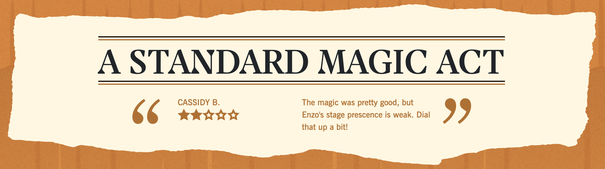

- How did you use the 3 meters and the “Show Earnings Report” throughout the game? | 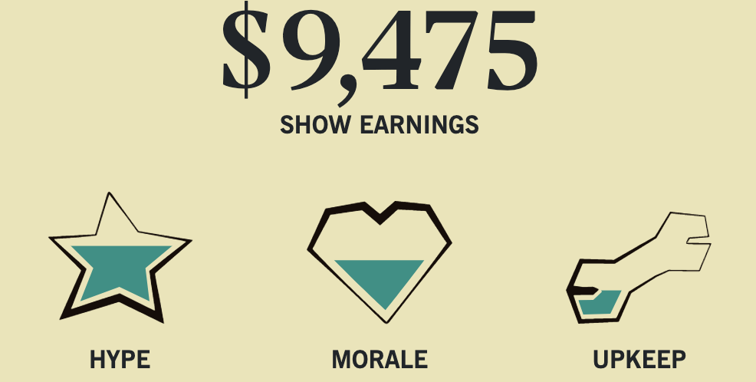

- Enzo’s goal was to save $50,000 to make his way to Vegas. How did having a fixed, predetermined goal impact your gameplay?

- What are three takeaways you learned from playing Money Magic that will help you when you create your own budgets in the future? Be specific.

