NGPF Activity Bank

Banking

Spanish version
INTERACTIVE: Online Bank Simulator

Interactive: NGPF Online Bank Simulator

Most banks and credit unions offer an online site for checking and saving accounts, allowing people to easily keep track of their account activity from the comfort of their own homes with a computer or smartphone. In this activity, you will use a simulation to practice navigating the features of an online bank account, so that you can feel prepared to use your own REAL online bank account!

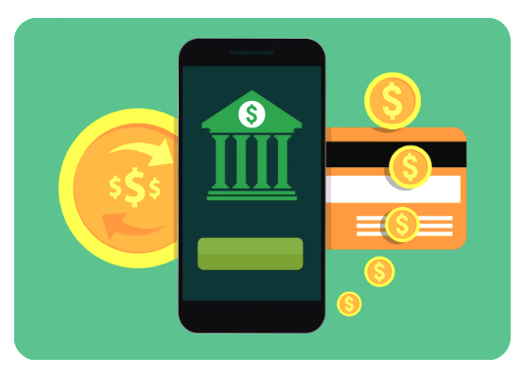
Note: This is a simulation and you should NOT use any of your actual bank account information at any point. Any names, addresses, and account information you see pre-entered are fictional.

Congrats on opening your very first checking and savings account last month! And you even deposited $250 into each account from the get-go.

- Open the NGPF Online Bank Simulator and click the orange button to access your account

Part I: Check that Checking Account
Now that you have your online account all set up and you are successfully logged in, let’s practice looking at the basics of your account!

- From the ACCOUNTS menu navigate to your ACCOUNT ACTIVITY page to view your CHECKING account transactions

- You’re brought to a page of all transactions that occurred in your checking account from the past month.
  - What is your current balance in the checking account?

  - Is it more or less than you started your account with?

- You want to make sure your account reflects the spending you’ve actually done, so you pull receipts out of your pockets from the last few weeks and find two from Snack Shack and one from a sale at Cool Clothes Co.
  - Are there any items reflected on your checking account that you don’t have receipts for? What are they?

  - What are 2 possible explanations that might explain the extra entry?

- To get in the full swing of things with online banking, you set up direct deposit with your job at Burger Bucket. You want to verify that it’s working correctly, and you know that you’re supposed to be paid twice a month.

- Use the blue calendar at the top right to advance one month into the future, then view your checking account activity again. You will remain on this date as you proceed through the simulation.
If the following month does not contain that date, move to the last day of that month.

  - How can you tell that your direct deposit works correctly?

  - What days did you receive your pay?

  - How large was each deposit? What is your checking account balance now?

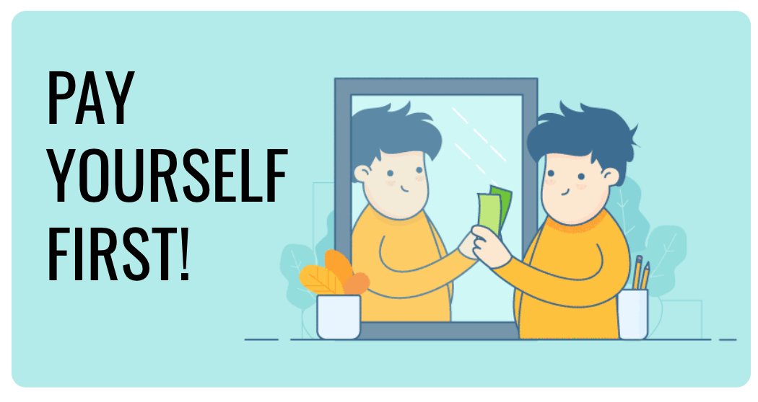
Part II: Switch Over to Savings!
Now that you’ve gotten a good look at your checking account, let’s switch over to your savings account.

- From your ACCOUNT ACTIVITY page, switch to view your SAVINGS account transactions

- What’s happened so far in your savings account?

Hmmm, thinking back to your personal finance course, you remember you should pay yourself first. By paying yourself first, you are regularly contributing some of your income to your savings account.

- How could you make sure that you are paying yourself first regularly and building up your savings?

- What payment frequency would best fit this goal of building up your savings? Why?

- Use the MAKE A TRANSFER feature to set up a recurring transfer of $60 to your savings account, starting immediately

- After the transfer, what are the new balances in your checking and savings accounts now?

Part III: Bills Bills Bills…
You’re working part-time, you’ve got your own bank accounts, and now it’s time to finally use a little of that financial independence!

- Navigate to the PAY BILL page

You’ve been wanting to freshen up your look, so you subscribe to the Wonderful Wardrobe clothing subscription service at a cost of $28 per month. You can’t be bothered to remember to pay on-time every month, so you want to set up auto pay.

- Use the dropdown menus to set up your monthly payment to Wonderful Wardrobe
  - You’ll need to add Wonderful Wardrobe as a recipient before you can send a payment
  - Your payment is due the fifth of every month.

- For what date did you set your first bill-pay to Wonderful Wardrobe? Why?

- Why is it important to know that it will take 5 business days to process your payment request?

You’ve just gotten your driver’s license, and your parents say you’re responsible for paying NoRisk Insurance Co. the first six months’ premium of $550 in order to be added to their policy. The sooner you pay, the sooner you can start driving.

- Use the dropdown menus to set up a single payment to NoRisk Insurance Co. for the earliest date possible
- Use the blue calendar at the top right to advance 5 days to the payment date
(You should now be 1 month and 5 days ahead of the date you started the simulation.)

- UH-OH! You receive a text on your phone telling you to check the NOTIFICATIONS zone for an important alert. Head there now. What do you see in your notifications?

- You’re worried about your Checking Account balance, so go check your ACCOUNT ACTIVITY. Should you be worried? Why or why not?

- What is one thing you can do to address concerns about your checking account balance?

- You’ll need to pay this insurance premium amount every 6 months. For future premiums, would you rather set up a single large payment or smaller monthly payments? Why?

Part IV: Shop ‘til You Drop!

Now that they’ve made you pay an insurance premium, your parents tell you you need to pay for your own gas, too!

- Navigate to the SHOPPING page and buy gas at Tank Fill 66

- What happens to your checking account balance?

- You can’t give the gas back, right from your tank! At this moment, what is the only thing you can do to fix your checking account?

- Take appropriate action to fix your checking account

- What are the balances in each of your accounts now?

- Use the blue calendar at the top right to advance one month into the future so you can get a few more paychecks into your account, and then return to the SHOPPING section.
(You should now be 2 months and 5 days ahead of the date you started the simulation.)
- Think of a typical month for you and some transactions that you might have. Use the calendar to advance to some random days through the month and add at least six shopping transactions you could see yourself making.
- Then, return to your ACCOUNT ACTIVITY page

- In which account do these transactions appear?

- What method of purchase would cause these to show up in this particular account?

- Looking at the total costs of your purchases, what surprises you about what you might spend in a month? How might seeing all your transactions along with your account balance help you adjust your spending habits?

Part V: Reflect
- Answer one of the following questions:
- If you already have a bank account, do you prefer to do in-person banking at the branch, online banking on a computer, or mobile banking from your phone? Explain why.
- If you don’t currently have a bank account, do you think you would prefer to do in-person banking at the branch, online banking on a computer, or mobile banking from your phone? Explain why.

