Multiple Filter Assignment

Directions:
- With a camera or your phone have someone take a close-up (portrait) picture of you. Portrait composition will be considered when marking. Create 12 identical images lined up on one canvas sized approximately 8” (width) x 9” height (portrait orientation), or vice versa (landscape orientation), with one different filter per image. You may want to crop your picture before taking it on to your canvas approx. 2” x 3”. See instructions on the video tutorials. You will find the links on my page. You should be using 300 resolution for your file.
- Leave the first picture as the original picture – label it “Original” using the Text tool.
- Each picture and its filter should be on its own named layer.
- Use the Filter Gallery to add some of your favourite filters to each picture. Don’t forget to convert for smart filters (Filter-Convert for Smart Filters).
- Use the Filter Gallery to add some of your favourite filters to each picture.
- Add two filters to one of the pictures. Click on the “New Effect Layer” button in the Filter Gallery (bottom right hand corner). You may have to abbreviate so the text fits on one line.
- Use the Text tool (in a very small font) on one of the corners to indicate what filter was used on each picture. Select a colour that will enhance the overall look.
- You can crop unwanted edges/background at the end.
- Post your final document to your weebly page under your Photoshop Assignments tab. NO CAPTION REQUIRED. You may have to shrink the size. Turn on your light box.

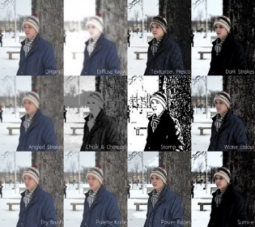
Sample:

