PHOTOGRAPHY CHALLENGE #1 - SCENE MODES

1) Go out and take pictures using the following scene modes:
- Portrait
- Landscape (some cameras do not have this option, USE AUTO INSTEAD)
- Macro (close-up)
- Sports
- Night portrait
Use the release-mode selector to take pictures using the continuous shooting mode (have a minimum of 3 pictures).
*note: continuous shooting mode (3 photos in a row) - shoot in auto no-flash mode (will not work in auto)
2) Select one picture for each of the scene modes (portrait + landscape + child + macro (close-up) + sports + night portrait. Select 3 continuous (must be in a row).
You should have 8 photos total.
3) Upload and save your files in your Scene Modes folder.
4) Rename your files accordingly:
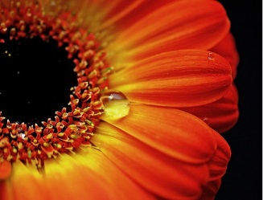
Example:
File name: SceneModes_Macro1_YourName
5) Save pictures to your “Scene Modes” folder (we will upload them to Weebly page later). Give your assignment a title. Label all photographs to indicate the camera setting that was used.

