PHOTOGRAPHY CHALLENGE – SYMMETRY

What is symmetry?

SYMMETRY refers to a line that splits an object in half and, if both sides of the object are an exact mirror image of each other, then this object is said to be symmetrical.

Depending on how you are holding the camera and how much of a scene you choose to show, you can strengthen or weaken the symmetric properties of an object or scene. Symmetry lets you automatically create harmony and a sense of aesthetically pleasing balance and proportion in a photograph.

Three types of Symmetry:

Vertical Line of Symmetry: If an object’s line of symmetry is perpendicular to the horizon line, it has vertical line of symmetry. In other words, if you split the photo in two (left to right), the left-hand side of your picture if very similar to the right-hand side of the picture.

Horizontal Line of Symmetry: If an object’s line of symmetry is parallel to the horizon line, it has a horizontal line of symmetry. If you split the photo in two (top to bottom), the top portion of your picture is very similar to the bottom of your picture.

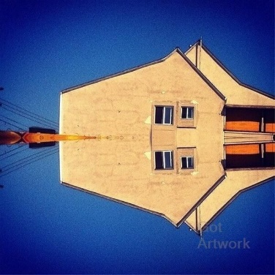

Vertical and Horizontal Lines of Symmetry: In this method you can replicate the image both vertically and horizontally. The top of your picture is similar to the bottom and the left-hand side is similar to the right.

Your Challenge:

Take one photo for each of the different types of symmetry (vertical, horizontal and both vertical and horizontal). You are not allowed to rearrange a scene to create symmetry; the symmetry must already exist in the scene! You will need to move around with your camera/phone and experiment with heights and angles.

Have an open mind and be creative!

Post 3 photos total on your Weebly under your Photography Assignments tabs:

- Photo that shows symmetry with a vertical axis
- Photo that shows symmetry with a horizontal axis. Challenge: try to capture horizontal symmetry that is not both vertical and horizontal.
- Photo that shows symmetry with both a vertical axis AND a horizontal axis

Add a caption to label the photos accordingly:
vertical axis horizontal axis vertical and horizontal axis

