Aperture & Depth of Field

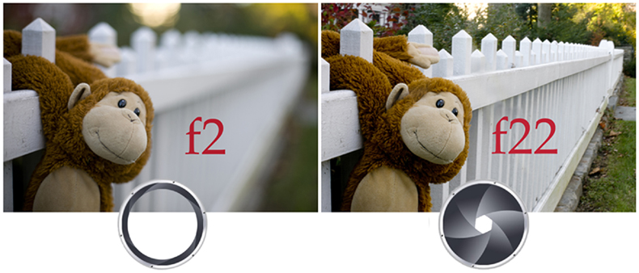
In this photoshoot you will find a subject matter of your choice; your image should include a subject or subjects that extends over some distance, you can't show depth of field with a flat subject. Therefore – have something in the foreground and something in the background. Think about bike racks, trees, flowers, building, vehicles, books, people, fences, piano keys, etc. If you are working with friends each group member must choose a different subject!

Shoot a series of photos with each subject experimenting with shallow and deep depth of field.

You will need two different compositions and three pictures for each composition. For one composition you may use the classroom props. For the second composition go around the school and look for different things. You will take a minimum of 4-5 photos of the same subject. In these photos you must have a different aperture ranging from a small aperture (F1.4) to a large aperture (F22). These images will give you a clear understanding of how the aperture works.

(Although you will only be posting 6 images (3 pictures for each composition) - be sure to take enough pictures to ensure clarity and quality of each aperture setting!!)

Remember that changing the focal length (Zooming the lens) will affect the changes in depth of field. Make sure you focus on your subject in the foreground.
All photographs should be posted individually, and should be labeled to indicate the aperture setting used to take them. Don’t forget to turn on your lightbox.

