PHOTOGRAPHY CHALLENGE - SHUTTER SPEED
4 pictures total (use Shutter Priority Mode for all). Upload them to your Weebly under your “Photography Assignments” tab.
Be sure to include the assignment title, sub-titles (Composition 1; Composition 2), and add text to label the shutter speed setting for each photo.

Compostion 1
First picture = subject and background in focus
Second picture = subject blurry, background in focus
Composition 2
First picture = subject and background in focus
Second picture = subject blurry, background in focus

TIPS/IDEAS:
- water fountain/water being poured
- ball bouncing/rolling/in the air
- person running/jogging/jumping
- long hair/fabric blowing in the wind
- pinwheel
- wind-up toys moving around
- globe
- flipping pages in a book
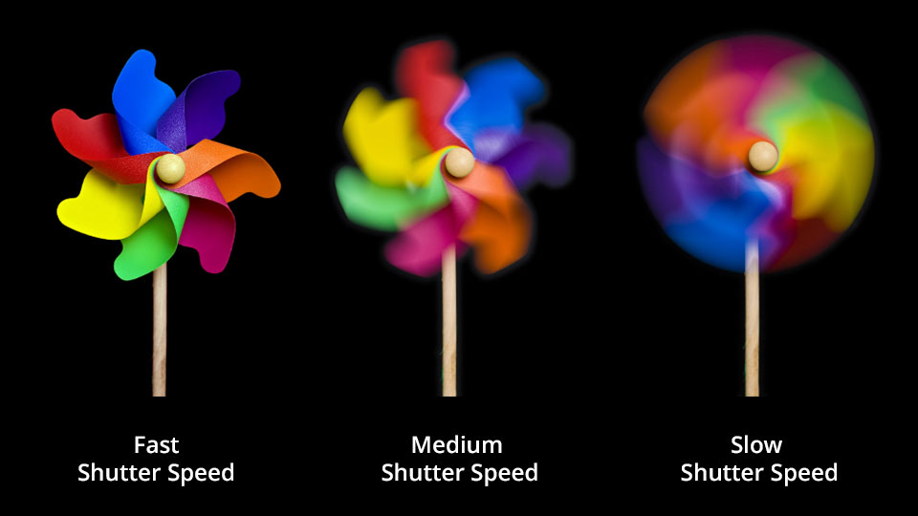
- moving vehicle/bike
1/250 1/30

