PHOTOGRAPHY CHALLENGE – TEXTURE

Choose something that has texture. You should bring something from home. Every student should have their own composition.
- Using a light source in the studio, photograph your item in 2 ways (try setting your camera to shutter priority 1/60, ISO 3200):
1 photo: least amount of texture (“flat” place your light – behind the camera lens – extended as high as it will go – pointing down towards your subject)
1 photo: most amount of texture possible (will involve shadows – light source at the side– same height and pointing towards your subject)
- Using a different light source (sunlight, flashlight on phone, lights in the school) photograph your item in 2 ways:
- photo: least amount of texture (“flat” lighting)

1 photo: most amount of texture possible (will involve shadows!)
.
Post 4 photos to your Weebly.

Label your photos as follows:
“Minimum Texture” (also include: aperture, shutter speed, and ISO settings)
“Maximum Texture” (also include: aperture, shutter speed, and ISO settings)

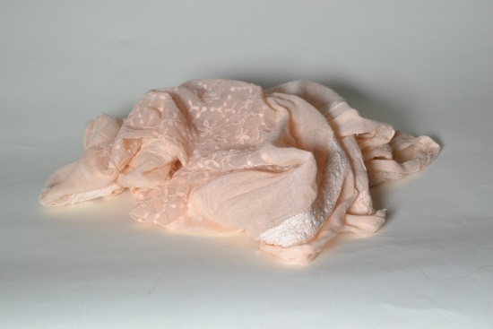
Examples:
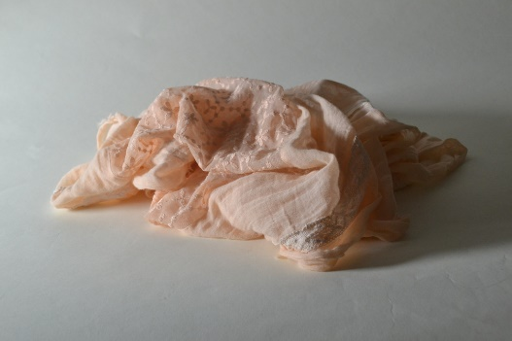

Minimum Texture (1/60, f10, 3200) Maximum Texture (1/60, f10, 3200)

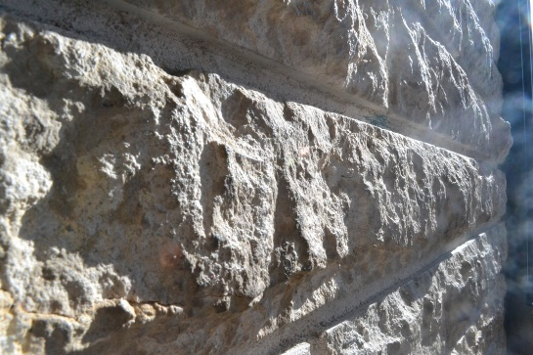
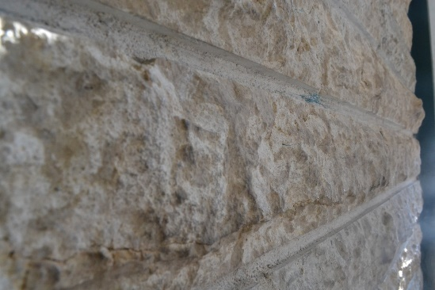

Minimum Texture (1/80, f12, 200) Maximum Texture (1/80, f12, 200)

